Table of Content

Background 3
Objectives 6
Organizing and Scientific Committee 7
Colloquium Programme 8
Views and Needs from the South 13
Feedback from the ministerial summit on health research 14
Feedback from the 8th Global Forum on Health Research 15
Tropmedeurop 16
The tropEd Network 20
Sentinel surveillance of imported Infectious diseases: Concept of TropNetEurop 23
COST action B22 on "Drug development for parasitic diseases" 24
European Network for the Diagnostics of "Imported" Viral Diseases (ENIVD) 25
Federation of European Societies for Tropical Medicine and International Health - FESTMIH 26
The SHARED SHARingpoint: networking networks 27
Models, management and quality of networking 28
European Microbicides Project - EMPRO 34
African Malaria Network promotes R & D across Africa 36
EUROLACTB: European, Latin American and Caribbean tuberculosis network 37
AARN: The African AIDS Research Network 38
Drugs for Neglected Diseases Initiative 39
Intra-EU programmes and their implication for developing countries: the example of TropNetEurope 40
EDCTP – the first year 41
Bottlenecks for new interventions in health care 44
Health system research in INCO-DEV: lessons from the past for the future 47
Health policy and research – Viewpoint of the Cambodian Ministry of Health 51
Research agencies and development 52
European academia and international health policies 53
NGO’s & international health policy 54
Networking for monitoring antimalarial treatment: EANMAT experience 55
The Supra-national Reference Laboratory (SRL) Network for tuberculosis 56
New Opportunities for joint training programmes in international health 58
Individual capacity strengthening: doctoral and post-doctoral training 59
Joint North – South training networks 61
The African and Malagasy Council for higher education and research 62
Institutional partnerships for training 63
North-South and South-South partnerships: experience from Sida/Sarec research support 64
Institutional capacity strengthening through ITM (Belgium) - NIMPE (Vietnam) collaboration 65
Institutional capacity strengthening through ITM (Belgium) – ITM Alexander von Humboldt, Universidad Cayetano Heredia Lima (Peru) collaboration 66
Recent Belgian networking initiatives in international health 68
Posters 70

International Colloquium

ANTWERP, 24 – 26 November 2004

EUROPEAN SCIENCE AND TRAINING FOR THE PROMOTION OF HEALTH IN DEVELOPING COUNTRIES:

NETWORKING THE NETWORKS

Background

Ill-health has ever been a major burden on daily life and general development in developing countries. Over the past decade, the spread of AIDS and old scourges such as malaria and TB, the emergence of new morbidity and failing public services, and the vicious cycle between poor health and poverty has brought entire countries and regions to the brink of disaster. A quick and decisive response should be an overriding priority for the affected countries as well as the international community. Apart from the humanitarian obligation, the impact on global prosperity and stability could otherwise be devastating.

While still being minute in comparison to military investments, political awareness in South and North have led to a number of global health initiatives and the commitment of substantial resources. The coherence and efficiency of the programmes is not yet optimal, and funds as well as absorption capacity are still far from sufficient. Yet, if the current efforts can be further strengthened, improved and sustained, hope for better access to health and health care is around the corner for millions of people.

Obviously, the affected countries must lead the programmes at the national and international level, and have (or must develop) the necessary capacity to that end. Yet, the challenges are so enormous and complex that the developed countries must not only provide money, but also whatever expertise they can deliver. However, they should avoid renewing the North-South dominance of the past, which has contributed all too often to the failure of meeting the true needs of the populations.

Social equity and accessible quality health care are main fundaments of most European nations and the European Union. In spite of persisting injustices, the European Union and its members are, on aggregate, the main partners of many developing countries. Both in terms of expertise and resources, Europe can thus contribute significantly to better health care for their populations. This much-needed impact does not yet reach its full potential, however, due to the fragmentation of many European efforts.

The co-ordination of development aid is mainly a matter of political will, and progress is being made. Scientists across Europe, of various disciplines contributing to international health development, have over the past decades taken several initiatives of their own to co-ordinate scientific research, advanced training, expert support and policy development in the field of international health. By the very nature of Europe, this is a matter of networking rather than centralisation. Formal and informal networks are now active in education, research and service delivery. Many have overlapping objectives and constituencies; most consist of a variety of (often the same) institutes, departments or individuals from Europe and, in most cases, also from the South. Yet, there has been no structured exchange or co-ordination between the networks far.

New European initiatives, such as those expressed in the Declaration of Lisbon (strengthening and bundling scientific research) and the Declaration of Bologna (establishing a European Higher Education Area) provide new momentum and perspectives for these networks. The European Union and individual members countries also provide instruments and resources to foster scientific cooperation, both within Europe and with the developing countries.

One of the earliest programmes is COST (European Co-ordination in the field of Scientific and Technical Research), for the co-ordination of nationally funded research. The COST-action B22 on “Drug development for parasitic diseases” is an example of such long-standing networks; while most of the work is laboratory-based, it is directly related to health in developing countries and it involves a good number of partners from the South. Previous EU Research Framework Programmes (FP) have created many small and temporary, project-based networks under the STD and INCO schemes, which among themselves were loosely connected in thematic “contract holder groups” (e.g. on malaria, schistosomiasis, health systems research...). While not being structural, the dynamics of these have often been perpetuated in long-standing north-north and north-south collaborative links. Under the FP5 and FP6 programmes, several “Concerted Actions” and “Accompanying measures” supported the co-ordination (but not the research as such) of larger groups. The Sixth Framework Programme takes the dynamics one step further by creating large “Networks of Excellence” and “Integrated Projects” which bring together most if not all important players in the EU and their international partners in a given field, supporting not only co-ordination but also joint projects. Finally, the European & Developing Countries Clinical Trial Partnership (EDCTP) for the first time joins “national programmes” and this in a separate and autonomous legal structure. Each of these models can be seen as a step further towards European integration, but in practice also show the many political, operational and managerial difficulties that have to be faced.

Other networks are more generic or demand-driven by nature. TropMedEurop (TME) is an association of institutes and schools of tropical medicine, which so far has concentrated on information exchange, joint advocacy and offshoots, but is seeking to play a more active role in European and international fora. tropEd (European Network for Education in International Health) is a network of TME members and other academia that organise jointly a modular advanced Masters in International Health. TropNetEurop (European Network on Imported Infectious Disease Surveillance) monitors main tropical import diseases in Europe. ENIVD (European Network for Diagnostics of Imported Viral Diseases) has been set up with support of the EU to monitor the possible introduction of haemorrhagic and other viral fevers in Europe. Several other networks and initiatives have a less pronounced but yet distinct European dimension, and/or are less explicitly aimed at but yet relevant for developing countries.

As the pressing needs in the field demand optimal co-ordination and efficiency, and in view of the new perspectives and instruments for European integration, it would obviously be useful for the existing networks working on international health development to exchange information and experiences, on their work as well as on their organisation model.

The colloquium

The Institute of Tropical Medicine of Antwerp (ITM) organises each year a colloquium on a topic of current relevance in tropical medicine and international health development, with support from the Belgian Ministry of Development Cooperation and other authorities and organisations. The specific aim is to bring together experts from different disciplines and backgrounds, and to ensure a balanced participation from South and North.

The ITM, active in many European and international networks, offers its 2004 colloquium as a forum for the various European networks active in international health development to exchange information and experiences, analyse opportunities for interaction and synergism, and possibly to structure future exchanges. This exercise will be done in dialogue with partners and actors from the South and with input from other international networks and initiatives. The meeting hopes to contribute to the bottom-up dynamics needed to structure a European “space” for scientific research, education and expertise for the improvement of health in developing countries. The venue will be Antwerp, 24-26 November 2004. Before and after the meeting the ITM is offering facilities for networks that wish to combine the colloquium with an internal (or joint) meeting.

The EDCTP, as a front runner and challenging experiment of European integration in the field of poverty-related diseases, will be a main co-sponsor of the event. Besides co-ordinating the national programmes for EDCTP-specific activities, it intends to link up also to relevant networks for training, capacity strengthening, pre- and post-clinical research. These networks may learn from, and be inspired by the EDCTP experiences – and vice versa. In the long term, a successful EDCTP may become the catalyst for further co-ordination and integration of the European efforts to improve health care and the fight against poverty-related diseases in developing countries. Therefore, the EDCTP-model will be in focus in most sessions.

The participants and target audience of the colloquium will be:

- Networks with a European dimension, active in scientific research, education or expertise in the field of tropical and poverty-related diseases and health care organisation in developing countries.
- South-partners of these networks and other representatives of developing countries active in those fields
- Representatives of other interested networks, organisations or international initiatives
- National and international authorities

European networks that have so far confirmed their commitment include:

- EDCTP - European and Developing Countries Clinical Trial Platform (EDCTP): a network of National Programs for clinical trials and capacity strengthening for AIDS, TB and Malaria from 15 European countries and their African partners, co-funded by the EU
- COST B22 - Drugs for Parasitic Diseases: a EU-supported network of research for anti-parasitic drug development
- TropMedEurop, the Association of European Institutes and Schools of Tropical Medicine and International Health
- tropEd, European Network for Education in International Health, organising a modular Masters of Science programme with 28 partner institutions from 13 countries.
- TropNetEurop, the European network on imported infectious diseases surveillance
- Several EU/FP6 Networks of Excellence (NoE), Integrated Projects (IP) or concerted actions (CA)

The ITM has invited and supports a substantial number of experts from developing countries, among others directors or representatives from key partner institutes in Africa, Asia and Latin America. EDCTP and some other participating EU-networks bring in a number of partners from the South. EDCTP grasps this opportunity to further explore and develop networking between national programs of EU countries and between Northern en Southern partners.

Objectives

The objectives and agenda of the meeting are:

- To exchange and disseminate information on the objectives, structure and activities of the various networks;
- To analyse their contribution to a “European Scientific Space” for research, education and training, expertise and policy development in international health;
- To analyse their contribution to the improvement of health and relevant capacity building in developing countries;
- To identify and structure potential areas of collaboration, co-ordination, synergy as well as current overlaps between different networks, areas (e.g. training and research), disciplines (e.g. shortening the development pipeline of new products) and thematic fields (e.g. different diseases);
- To exchange experiences and problems related to the structure, mechanisms, management and funding of the networks;
- To jointly reflect on further needs and possible steps for strengthening European and international co-ordination and positioning in the scientific fields related to international health development;
- To provide an early feed-back on the outcomes of the Ministerial Summit and 8th Global Forum on Health Research (Mexico, 16-20 November 2004).

Organizing and Scientific Committee

Organizing Committee

ITM

Dr. Jan Clerinx
Prof. Dr. Stanny Geerts
Prof. Dr. Bruno Gryseels
Prof. Dr. Jef Van den Ende
Dr. Dirk Van der Roost
Dr. Govert Van Heusden

Scientific Committee

Prof. Dr. Stuart Anderson, London School of Hygiene and Tropical Medicine, UK
Prof. Dr. Marleen Boelaert, ITM, Antwerp, Belgium
Prof. Dr. Simon Croft, DNDi, Switzerland
Prof. Dr. Stanny Geerts, ITM, Antwerp, Belgium
Prof. Dr. Bruno Gryseels, ITM, Antwerp, Belgium
Prof. Dr. Tomas Jelinek, Institute of Tropical Medicine, University of Berlin, Germany
Prof. Bernt Lindtjørn, Executive Director, EDCTP, Den Haag, The Netherlands
Prof. Dr. Carsten Mantel, Institute of Tropical Medicine, University of Berlin, Germany
Prof. Dr. Fred Opperdoes, UCL, ICP, Brussels, Belgium

Colloquium Programme

Monday 22 November - Wednesday 24 November 12 a.m.

Opportunity for internal or joint meetings of the networks

WEDNESDAY 24 NOVEMBER – p.m.

SESSION I INTRODUCING THE NETWORKS

Moderator: Eduardo Gotuzzo - ITM Lima, Peru

Rapporteur: Katharina Kober - ITM, Belgium

14 – 18 u

14.00 | Bruno Gryseels (ITM, Belgium) | Welcome address
14.20 | Getachew Desta (Addis Abeba University, Ethiopia) | Views and needs from the South
14.40 | Wim Van Damme (ITM, Belgium) | Feedback from the Ministerial Summit on Health Research
 | Andres de Francisco (GFHR, Switzerland) | Feedback from the 8th Global Forum on Health Research
15.15 | Discussion
15.25 | Coffee Break
15.50 | Presentation of co-organising European Networks
 | Bruno Gryseels (ITM, Belgium) | TropMedEurop
 | Carsten Mantel (University of Berlin, Germany) | tropEd
 | Tomas Jelinek (University of Berlin, Germany) | TropNetEurop
 | Fred Opperdoes (UCL, ICP-TROP-Belgium) | COST – drug development for parasitic diseases
 | Martin Boeree (ULC Dekkerswald, Netherlands) | FESTMIH
 | Matthias Niedrig (Robert Koch Institute, Berlin, Germany) | ENIVD
 | Agnes Soares (SHARED, The Netherlands) | SHARED
17.00 | Barbara Simaeys (South Research, Belgium) | Models, management and quality of networking
17.30 | Discussion

19.30 Academic Session (II), Elzenveld, Lange Gasthuisstraat, Antwerp

19.30 Official address

Geert Bourgeois, Flemish Minister of Foreign Policy

- Eric Duchêne, Federal Directorate-General for Development Cooperation

- A representative of EC

Key note lecture: Global health challenges and development

- Pascoal Mocumbi – Former Prime Minister of Mozambique and
(EDCTP – High Representative)

20.30 Reception

THURSDAY 25 NOVEMBER

SESSION III NETWORKING IN RESEARCH – FROM MOLECULE TO PATIENT

Moderators: Marleen Temmerman - ICRH, Ghent

Rapporteur: Francine Matthys, ITM, Belgium

9.00 | Guido Vanham (ITM, Belgium) | EMPRO - Microbicides research
 | Sodiomon Sirima  (CNLP, Burkina Faso) | Vaccine research: AMANET
 | Juan-Carlos Palomino  (ITM, Belgium) | Diagnostics: Tuberculosis
 | Souleymane Mboup  (CHU, Senegal) | AARN: The African AIDS Research Network
10.30 | Coffee Break
11.00 | Simon Croft (DNDi, Switzerland) | Drugs for neglected diseases
 | Tomas Jelinek (University of Berlin, Germany) | Intra EU programmes and their implication for developing countries
 | Bernt Lindtjørn (EDCTP, The Netherlands) | EDCTP: the first year
 | Francine Matthys (ITM, Belgium) | Bottlenecks for new interventions in health care systems
12.30 | Discussion  Key discussant: Els Torreele  (DNDi, Switzerland) | How can networking shorten and improve the development pipeline?
13.00 | Lunch

SESSION IV NETWORKING IN HEALTH POLICY AND RESEARCH

Moderator: Vincent Janssens - MSF, Belgium

Rapporteur: Bruno Meesen - ITM, Belgium

14.00 – 17.30

14.00 | Goran Tomson (Karolinska Institutet, Sweden) | Health systems research in INC0-DEV: lessons from the past for the future
 | Chhi Vun Mean  (MOH, Cambodia) | Health ministries and research
 | Coenraad Krijger  (NWO, The Netherlands) | Research agencies and development
 | Don de Savigny  (STI, Switzerland) | European academia and international health policies
15.30 | Coffee Break
16.00 | Gombe Spring (Health Action Intl., The Netherlands) | NGO’s and international health policies: the case of TRIPS
 | T.K. Mutabingwa (EANMAT, Tanzania) | Case study: networking for monitoring drug resistance: Malaria
 | Armand Van Deun  (ITM, Belgium) | Case study: networking for monitoring drug resistance: Tuberculosis
17.00 | Discussion  Key discussant: Souleymane Mboup (CHU, Senegal) | How can networking strengthen policies and practices of health care and disease control?

19.00 Visit, reception and walking dinner at the Antwerp Town Hall, Grote Markt 1, Antwerp

FRIDAY 26 NOVEMBER

SESSION V NETWORKING FOR EDUCATION, TRAINING AND CAPACITY BUILDING

Moderator: Catherine Hodgkin - KIT, The Netherlands
Rapporteur: Govert van Heusden – ITM, Belgium

9.00 | Carsten Mantel (University of Berlin, Germany) | The European higher education area: new opportunities for joint training programmes in international health
 | Stuart Anderson (LSHTM, U.K.) | Doctoral and post-doctoral training
 | Penali Kone (CAMES, Ivory Coast) | Career structures for developing countries scientists
 | Christophe Hatz (STI, Switzerland) | Joint North-South training programmes
 | Sylvia Sax (University Heidelberg, Germany) | Institutional partnerships for training
11.00 | Coffe Break
11.30 | Hannah Akuffo (SIDA, Sweden) | North South and South South partnerships
 | Eduardo Gotuzzo (ITM, Lima, Peru) | Models and case studies: how can developing countries take the lead
 | Ho Dinh Trung  (NIMPE, Vietnam) | Models and case studies: how can developing countries take the lead
12.30 | Discussion  Key discussant: Fabio Zicker (TDR – Switzerland) | The role of networks in capacity strengthening and innovative training initiatives
13.00 | Lunch

SESSION VI CONCLUSION

14.00 – 16.00

Moderator: Pascoal Mocumbi (EDCTP, The Netherlands)

14.00 Summary of meetings by rapporteurs
Panel and plenary discussions: EU-officials, representatives from networks
Europe and international health
Relation between EU networks and developing countries
Outcome of the meeting
Conclusion and closure: organisers

Panellists:

Arnd Hoeveler, DG Research, Lifescience Programme
Anna Karaoglou, DG Research, Inco Programme
Bernt Lindtjørn, EDCTP, The Netherlands
Getachew A. Desta, Addis Abeba University, Ethiopia
Eduardo Gotuzzo, ITM, Lima, Peru
Catherine Hodgkin, Koninklijk Instituut voor de Tropen, Amsterdam
Don de Savigny, Swiss Tropical Institute, Basel
SESSION I

Views and needs from the South

G.A. Desta, Addis Abeba University, Ethiopia and EDCTP Developing Countries Co-ordination Committee, Den Haag, The Netherlands

This presentation was prepared with the help of Dicky Akanmori, Noguchi Memorial Institute, Ghana and Chair of EDCTP DCCC.

This presentation will give some examples of current African networks with their characteristics

Current landscape in health research in Africa

- Traditional Disease-specific networks – Malaria, TB, HIV/AIDS
- Networks based on common language – Paludisme Plus (French-speaking)
- Regional networks – West African Network of Plant medicine research, East African Network on Malaria Treatment etc.
- Institutional networks

Characteristics of an ideal network

- Free flow of information
- Should be Virtual with access from anywhere
- Should address all three major diseases (HIV/AIDS, Malaria, TB)
- Should be able to attract adequate funding
- Should be based in Africa.
- Leadership and ownership must be African

Players in an ideal network in Africa

- Heads of Health Research Institutes
- African Research Scientists and clinicians
- European Research scientists
- Disease/Program Managers
- Medical Associations
- Industries
- Community Opinion Leaders
- Relevant Non-Governmental Organisations

Feedback from the ministerial summit on health research

W. Van Damme, Department of Public Health, Institute of Tropical Medicine, Antwerp, Belgium, wvdamme@itg.be

This presentation was prepared with the help of Yogan Pillay, Ministry of Health,
South Africa, Member of the EC-INCO Expert Team.

The Ministerial Summit on Health Research, organized by the World Health Organization and hosted by the Mexican Government, focuses on the country level: action on health research and knowledge management to strengthen health-sector response to achieve the MDGs.

This is the first time a Ministerial Summit on Health Research takes place. This summit should give birth and lead to the launch of the ‘Mexico Agenda on Health Research’

The themes of the Summit are:

- Access and Sharing of knowledge
- Innovation, Product and Method Development, and Evaluation
- Civil Society, Gender and Ethics
- Social, Environmental and Economic Determinants
- Health Systems Research and Research to Policy/Practice Links
- Organization and Funding of Health Research

Feedback from the 8th Global Forum on Health Research

A. de Francisco, Deputy Director, Global Forum on Health Research, Switzerland

Background
The Millennium Development Goals (MDGs) adopted by the United Nations in 2000 provide an opportunity for concerted action to improve global health. They place health at the centre of development and establish a novel global compact among developed and developing countries through clear, reciprocal obligations. However, despite revolutionary progress in biomedicine, research advances and new knowledge are not reaching populations in greatest need.
At present rates of progress, the MDGs will not be realized for a majority of the world's population. There is an urgent need to create new products and tools and to identify structures and means to translate knowledge to effective intervention. This will require the development of delivery strategies that achieve effective and sustained coverage in diverse cultural and economic settings. It also may require a fundamental restructuring of interaction between the research, disease control and development communities, a systematic programme of research related to building capacity at multiple levels, from operational research through community-based intervention.
Forum 8 will focus on global efforts to expand health research in neglected areas to support the achievement of the MDGs.
The Ministerial Summit on Health Research
Forum 8 will take place in parallel to the Ministerial Summit on Health Research, organized by the World Health Organization and hosted by the Mexican Government. The Summit will focus on the country level: action on health research and knowledge management to strengthen health-sector response to achieve the MDGs.
The Summit and Forum programmes include a number of joint sessions: the opening ceremony, a plenary session and coffee break each morning, evening receptions and the closing plenary.

Who will take part?
The Global Forum's annual meeting provides the opportunity for presentations and exchange of views on key issues on the global health agenda.
This year's theme allows examination of health research needed to meet each of the MDGs. In addition, it poses questions of health priorities not covered by the goals themselves.
Participants from a broad range of constituencies are expected to be present: health and development ministries, multilateral and bilateral agencies, research-oriented bodies and universities, NGOs, the private sector, the media.

Tropmedeurop

B. Gryseels, Director, Institute of Tropical Medicine, Antwerp, Belgium – bgryseels@itg.be

Background

Worldwide inequity in health and health care, caused by poverty, infectious diseases and lack of access to adequate health services, and dramatically aggravated by the AIDS-epidemic, is one of the greatest social, economic and political challenges of the 21st century. A thousand statistics can be summarised by the estimated daily loss of 35.000 young lives due to curable or preventable communicable diseases in the developing world. This humanitarian drama is also at the basis of worldwide social, economic and political problems such as uncontrolled migration, societal instability and the deterioration of grow markets, and is therefore also a major threat to the "Global Village", and Europe in particular. The improvement of the impact and efficiency of existing interventions, as well as the development and introduction of new tools and strategies, require intensified, well-co-ordinated research efforts and comprehensive expertise. Both the disease systems (biological, clinical, epidemiological, applied technology) and the health system (access, quality, efficiency and sustainability) must be addressed in a comprehensive strategic approach.

The role of Europe

In the industrialised world, Europe can provide unparalleled capacity, commitment and leadership. Combined, the European member states have by far the greatest capacity in the world for research and control of poverty-related, communicable and tropical diseases, and health development in general. However, due to historical and political reasons, much of the work in the past was done in a strictly national framework. Apart from the obvious under-exploitation of scientific synergy and efficiency, this fragmentation has also caused lack of co-ordination, and even counterproductive competition, in their collaboration with the developing countries and in the international arena. Moreover, due to the decline of the colonial and post-colonial interests, many states have reduced their investments in international health research, whereas in fact the needs have never been greater, be it in a very different framework. Consequently, Europe's position is not yet as strong as it could and should be in the field of international health research and development. In addition, the developing countries and international agencies are expecting a strong input from Europe, which has indeed its own exemplary social health care systems to show.

Over the past decade, national and EU-programmes have allowed to create small networks within Europe and with the South, and to considerably strengthen capacity in the developing countries. However, these networks were project-based, limited in time, scope, resources and collaborative power. Nevertheless, they have clearly shown the enormous potential, need and demand for a broader, more structured and long-term co-ordinated international health research, within Europe and with the South. The sixth Framework Programme provides new perspectives and instruments to shape a true European research space in international health, in particular regarding major poverty-related and communicable diseases; to unite forces to face the research needs of the health crisis in the South; to consolidate and strengthen the European profile and its leading role in this global challenge.

The role of TropMedEurop

TropMedEurop (TME) is the European Association of Institutes and Schools of Tropical Medicine and International Health. Over the past years, TME has evolved from a personal network of directors of "classical" Schools of Tropical Medicine to an association uniting most European scientific institutes working on international health and tropical diseases. Main, independent offsprings are TropEd (European Master programme in International Health) and TropNet (surveillance of import diseases), which are described elsewehere. In the fields of research, capcity strengthening and international health policies TME still has to develop to its full potential. European and other international programmes have led to the creation of project-based and thematic networks, without an over-arching institutional coordination policy however. Thus, the networks are fragmented and limited in scope and time. On the other hand, they show the vast potential of a structured "European Research Area" for global health development, and for a coordinated collaboration with the developing countries. Capitalising on its scientific excellence, collaborative partnerships and societal values, Europe can and must indeed play a major role in global health development.

TropMedEurop intends to contribute to this ERA by coordinating the strategies, activities and standards of its members. It will, moreover, broaden this ERA to a European "Scientific Area" which includes also training and capacity strenghtening and world-wide collaboration. It will build on the individual and common expertise of its members, which include virtually all players in this field in the EU, and on their collaborative networks within Europe and with third parties, particularly those in the South. It will also capitalise on the unique profile of Europe in this field, historically grown through its own social and political evolution, its relations with the South, its cultural diversity and its scientific excellence. This ERA should also strengthen the role and voice of Europe in global efforts to combat AIDS, malaria, TBC and other poverty-related and communicable diseases, to improve universal access to sustainable quality health care, and to ensure that globalisation contributes effectively to poverty reduction and equity. It should allow the partners in the developing countries to better coordinate and lead their collaboration with European researchers, institutes and countries.

Plan of action

The strategy to build up TropMedEurope's contribution to this European Scientific Area will be bottom-up, low-cost, gradual, voluntary and complementary to institutional, national, European and joint programmes and networks. In a first phase, the network will mainly focus on co-ordination and integration. However, once its co-coordinative capacity is strengthened, the consortium could also initiate and run network projects, and/or manage research programmes on behalf of the EU or other agencies.

- Strengthening the legal, operational and scientific profile of TropMedEurop, and reinforce its co-ordinating capacity within Europe and with the southern networks.
- Exchanging and enhancing access to information (common databases and websites), expertise (mutual and joint consultation and institutional peer-review), programmes and networks, staff (exchanges of junior and senior scientists), joint scientific training programmes (e.g. European post-graduate accreditation and joint PhD projects), clinical services (expertise, diagnostics, surveillance).
- Promoting, supporting, bridging and, where useful, initiating relevant thematic networks, integrated projects and other national and transnational programmes on poverty-related and communicable diseases, including joint EU-programmes such as the European-Developing Countries Clinical Trial Partnership (EDCTP).
- Bridging and integrating biomedical, clinical, epidemiological and intervention research in order to improve relevance, quality, efficiency and applicability.
5. Co-ordinated support to, and dialogue with national, European and global authorities and programmes, and joint advocacy in the international health fora.
6. Initiate and manage European research and capacity building programmes.

Expected outcome

Expected Results | Potential Users
Co-ordination of European research in international health | Institutes, networks and researchers; EU, national and joint programmes; training programmes; tropical and emerging disease surveillance in Europe
Better knowledge of pathogens and host interactions | Scientific and medical communities; industry; patients
Improved tools and strategies for case management, prevention and control of poverty-related and communicable diseases | Health ministries; international agencies; health services and systems; patients and populations; industry; world community
Strong leadership of Europe in international health and global disease control | European and national political and scientific authorities; international agencies; southern partner countries; target populations

Contribution to economic development in Europe and its partner countries

One of the main problems in the fight against poverty-related diseases is the lack of incentives to invest in product development and marketing. The deficiencies are situated not only downstream (lack of health services as a market, global market mechanisms), but also mid-stream (lack of capacity for clinical trials and intervention research) and upstream (insufficient critical mass in academia for basic research and industry partnerships). Yet, given the enormous number of patients, also in strong growth markets, and the rapidly increasing international support, a huge potential market could be exploited.

The mid-stream gap has already been identified and will be responded to by the European / Development Countries Clinical Trial Partnership (EDCTP), in the development of which many consortium members actively participate. TropMedEurop will stimulate and co-ordinate their further contributions to planning and implementation, and stimulate participation and co-ownership by its southern partners.

TropMedEurop can contribute considerably to filling the economic downstream gap. Through its intervention and health systems research, it can identify technical, socio-economic and institutional obstacles and solutions to the introduction and marketing of new or improved products (diagnostics, drugs, vaccines, commodities). It will call on the industry and development agencies to complement these efforts with their own expertise and resources.

TropMedEurop could also help filling the upstream gap, by pooling critical mass and resources, and possibly by acting as a joint forum and/or support secretariat (e.g. for legal and patent issues) to deal with the industry e.g. in private-public partnerships for basic research and technology development.

Current members and their expertise

TropMedEurop unites, since several decades, virtually all European schools and institutes involved in research, training and services in the fields of tropical medicine and international health development. Besides the EU member states, Switzerland, Norway and most states of Eastern Europe are represented in TropMedEurop. Most members have extensive collaborative networks in the South and participate actively, usually in collaboration with several members and southern institutions, in health, research and development programmes of the EU.

The members are active in virtually all relevant fields: AIDS, Malaria, TBC; other communicable and poverty-related diseases; health systems research; international health policies; national and international food safety and security, the impact of globalisation and climatic changes on health. Disciplines include fundamental and applied genomics proteonomics, biochemistry, immunology; clinical research and trials and product development; field and vector biology, epidemiology and modelling; sociology, anthropology and economics. The potential of crosscutting fertilisation and innovation, between institutes, themes and disciplines, is enormous and still far underexploited. Many of the infectious agents studied provide unique generic models for basic biology, human immunology and pathofysiology.

European Network for Education in International Health

The tropEd Network

Dr. C. Mantel, MPH, Head, International Health Department, Institute of Tropical Medicine, Charité University Medical School ,Humboldt and Free University Berlin, Spandauer Damm 130, D-14050 Berlin, Germany. Also Executive Secretary tropEd
Tel: (+49 30) 30116767 Fax: (+49 30) 30116888 email: carsten.mantel@charite.de

tropEd is a network of European institutions for higher education in international health. It collaborates closely with institutions in Africa, Asia and Latin America. tropEd provides postgraduate opportunities for education and training contributing to sustainable development. It focuses on improving the management of health services for disadvantaged populations. The innovative approach is based on mobility of people, the exchange of experiences in different disciplines and the establishment of a common standard in education and training.

International Health

International Health is a discipline that systematically compares factors that affect the health of all human populations with a special focus on poverty-related health problems in low- and middle-income countries. International Health includes the promotion of health, prevention and treatment of diseases and rehabilitation. Knowledge, skills and the ability to critically analyse and draw implications for practice related to the major endemic diseases, health systems research, health economics, health policy and management of health services are essential.

Career Opportunities

A large number of trans-national organisations and national development agencies strive to overcome the obstacles to gaining global health. Besides these there are non-governmental organisations of all types, including religious agencies or independent groups, universities and other specialised academic settings as well as a growing number of private for-profit or nonprofit consulting firms. All of these organisations need qualified personnel with formal training in International Health.

The tropEd Masters Programme in International Health

The degree programme is characterised by a unique synergy of experience and expertise of leading European institutions. It prepares people to work more effectively in a multicultural environment by exposing them to multiple perspectives and offers a flexible structure with the Europe-wide recognition of education. The programme is open to students world-wide.

Content, Structure and Duration of Training

The Masters Programme in International Health is offered across tropEd member institutions. The modular programme for full-time or part-time study consists of an introductory core course, specialised optional modules and a research project submitted as a thesis. It is intended for completion within a minimum of one year (full-time) up to a maximum of five years (part-time). Studies comprise a number of public health-related disciplines including anthropology, biology, economics, education, environmental health, epidemiology and statistics, management studies, nutrition, population sciences and reproductive health, psychology, social sciences research, sociology, travel and migrant health and tropical medicine with a focus on infectious diseases, parasitology, virology, bacteriology and laboratory practice.

Students normally carry out their studies as follows:

- Registration at their home institution which will provide tutorship for students throughout the programme.
- Completion of the core course at the home institution which is equivalent to three months of full-time study.
- After successful completion of the core course, students select optional modules, which may be taken at various partner institutions and are collectively equivalent to 3-6 months of full-time study. Modules are selected from a list of tropEd-accredited courses (at http://www.troped.org) according to the interests and experience of participants.
- Students carry out a research project submitted as a thesis, equivalent to a further 3-6 months of full-time study, normally at their home institution.
- Six predefined study tracks are offered for full-time students wishing to complete their studies within a year. These tracks are: Tropical Medicine and Disease Control; Health Systems, Health Policy and Management; Sexual and Reproductive Health; Child Health; Health Research Methods; and Health in Emergencies.
- Students obtain a Masters degree when: all three stages and an oral examination have been successfully completed; studies have taken place at a minimum of two member institutions in different countries; and they have gained at least two years professional experience in low- or middle-income countries by the time the degree is awarded.

European Credit Transfer System (ECTS)

The European Credit Transfer System (ECTS) facilitates transfer of course credits between institutions at the same academic level. A total of 60 ECTS credit points must be accumulated for successful completion of the programme. A student work load of 30 hours formal teaching and private study (student investment time) is equivalent to one ECTS credit point.

Admission Requirements

Selection of participants is guided by a programme emphasis on a multidisciplinary approach to international health. Students are recruited from a variety of backgrounds including medical doctors, nurses, social scientists, health educators, and health managers. Applicants must hold a first degree - at least equivalent to a Bachelor’s degree - in a relevant field. Each application is individually assessed. Admission requirements vary slightly between home institutions.

Application Deadline and Beginning of Programme

Please check the webpages of the tropEd home institutions.

Language

The major programme languages are English, French, Spanish and Portuguese. A sound knowledge of the English language is considered necessary for the successful completion of the programme. In most institutions, proficiency in English is required and must be demonstrated by a TOEFL score of at least 550 points paper-based or 213 points computer-based, or an equivalent approved test.

Degree

Master of Science in International Health degree awarded by the home institution or a multiple European Master of Science degree in International Health from each of the main institutions they studied at, with a diploma supplement which describes their study track. A written recognition of the Masters-level training is provided to each successful participant by the tropEd Secretariat as a statement about standards in education and training in the tropEd member institutions, as all provision is subject to external quality assurance.

Tuition Fees

Module and course fees are based on the current fee requirements of the local tropEd institution. On average there is a fee of approximately 150 € per credit point for core training, 200 € per credit point for the optional modules and of 50 € per credit point for the research project and thesis work. Tuition varies widely, however, from country to country. Tuition for the overall Masters programme will amount to approximately 8,000 to 10,000 € depending on the courses and institutions selected. Living expenses including accommodation amount to approximately 650 € per month; they vary greatly between countries.

Scholarships and Students’ Support

Participating institutions may assist tropEd students in obtaining total or partial financial support. A number of Erasmus Mundus scholarships is available to full-time students from non-European countries with an outstanding academic or professional record. These scholarships are awarded on a highly competitive basis, requests should be addressed to the tropEd Secretariat. Students are encouraged to apply for financial support in their home countries.

Sentinel surveillance of imported Infectious diseases: Concept of TropNetEurop

T. Jelinek, Chairman, TropNetEurop, Institute of Tropical Medicine, University of Berlin, Germany

TropNetEurop, the European Network for Surveillance of Imported Infectious Diseases, has been launched in February 1999. Forty-six infectious disease clinics from 17 European countries are currently participating in this scheme.

Targets are:

- to provide grounds for preparation of diagnostic and therapeutic guidelines for the management of imported infections within Europe;
- to identify emerging pathogens by sampling returning international travellers, immigrants, and foreign visitors;
- to identify trends in specific agents, risk factors, clinical outcomes, and microbial resistance patterns in imported infectious diseases;
- to provide grounds for multi-centre research on imported infectious diseases in Europe;
- to foster epidemiological and clinical teaching of infectious diseases within Europe, and
- to assist the international exchange of data on emerging and re-emerging infectious diseases.
COST action B22 on "Drug development for parasitic diseases"

F. R. Opperdoes, Chairman, ICP-TROP, Avenue Hippocrate 75, B1200 Brussels, Belgium

COST B22 is a European action in the framework of the "Cooperation in Sciences and Technology" (COST) programme of the European Commission. The action comprises in addition to 15 European countries, Israel and Canada and is associated with non-governmental organisations such as the "International Organization for Chemical Sciences in Development" (IOCD) and the "Drugs for Neglected Diseases initiative" (DNDi), who are involved as observers. The action has started in 2002 and runs for five years. The aims of the action are the development of new and better drugs for parasitic diseases, mainly those of the Tropics, such as African sleeping sickness, Chagas' disease, the various manifestations of leishmaniasis and malaria. Other diseases such as trichomoniasis, amaebiasis and giardiasis are also included. For most of these diseases the available drugs are limited and often resistance for them by the parasites renders them highly inefficient. In order to improve the present situation the COST B22 participants have created 5 working groups.

These are:

- Working Group 1: “ Drug target identification”
- Working Group 2: “ Target characterisation and inhibitor design”
- Working Group 3: “ Drug evaluation”
- Working Group 4: “ Preclinical Research/Development”
- Working Group 5: “ Drug Resistance”

Each group makes a detailed analysis of the current situation. To address the problems identified they organise specific activities, such as expert meetings and/or the exchange of scientific personnel between their laboratories. Once per year all groups meet during their annual congress to present their progress, to exchange ideas and to inform the scientific community and the public. Meeting costs are covered by COST and funding from IOCD allows to invite a number of Third-World participants. Scientific results and meeting reports are being published. A website describing the details of the action is available at http://www.icp.ucl.ac.be/cost/costB22/.

European Network for the Diagnostics of "Imported"
Viral Diseases (ENIVD)

M. Niedrig (Chairman ENIVD) & ENIVD Members, Robert Koch-Institut, Berlin, Germany

Further information on www.enivd.de or www.enivd.org

In the last decades we became aware of the emergence of several viral disease outbreaks in humans which have their origin in non-human species. Many, like Ebola, and Nipah and recently SARS, passed the species barrier and cause fatal diseases in humans with close contact with these animals. Through the imported Yellow Fever, Lassa and SARS cases to Europe we all became aware that these dangerous infections could be imported to Europe from endemic regions in a very short time.

In eleven meetings scientists from laboratories working in the field of diagnostics of "imported" viral diseases in the U.K., Sweden, France, Greece, Spain, Denmark, Netherlands, Belgium, Portugal, Finland, Italy, Ireland, Slovenia, Lithuania, Switzerland, Bosnia-Herzegovina, Czech Republic, Slovakia, and Germany have started to build up a network to improve the diagnostics of "imported" viral infections and have worked out objectives to be addressed in this collaboration:

- Build a network of European laboratories working on diagnostics of "imported", rare and emerging viral infections. Provide mutual help in the exchange of diagnostic samples, i.e. sera, viruses, methods, and information in order to improve diagnostics.
- Identify those viral infections more likely to be imported and co-ordinate the objectives and identify laboratories, capable and willing to perform the rapid diagnostics (<24h) of an acute case, suspected to be infected with a viral haemorrhagic fever.
- Work out recommendations for standardisation and quality control in diagnostics laboratories involved in the diagnostics of such diseases.
- Identify and operate standard assays according to defined quality control criteria.
- Optimise limited resources by exchanging reagents, methodologies, and expertise.
- Encourage regular contact within the network through meetings, exchange and training of laboratory personnel.
- Open the network for members of other European laboratories.
- Organise and co-ordinate international activities with the "Surveillance network group" or other national like CDC or international organisations WHO and PAHO.

The ENIVD provides its members with continuous information on outbreak situations and shares information on outbreak investigations, diagnostic methods and expertise. This is also achieved by regular meetings which provide an excellent opportunity to gather information on an informal basis.

In the last two years we performed some external quality assurance evaluations. Two for serology of Hanta and Dengue diagnostics and one for Dengue PCR diagnostic. Further EQAs for evaluation of PCR diagnostics for Ebola, Marburg, Lassa, Orthopox and SARS are performed and will be repeated soon. The ENIVD is presently funded by the DG SANCO (SPC.2002396) under the program AIDS and other communicable diseases.

Federation of European Societies for Tropical Medicine and International Health - FESTMIH

M. Boeree, Chairman,FESTMIH, Groesbeek,ULC Dekkerswald, Groesbeek, The Netherlands (contact: www.festmih.net)

Mission

The Federation was founded in 1995 at Hamburg, during the first European Conference on Tropical Medicine. Fifteen European countries are currently represented on the Federation Council by their respective national societies. Overseas Societies are welcomed as corresponding members.
The objectives of the Federation are to build upon the interdisciplinary expertise of the national Societies in Europe, for developing European collaboration and North-South partnership towards health development in the tropics, in the respect of regional specificities. The Federation wants specifically to promote harmonisation of health strategies and recommendations related to developing countries, emergency situations and Federation of European Societies for Tropical Medicine and International Health FESTMIH research priorities, to foster the formation in the tropics of new scientific societies dealing with health sciences, to encourage European harmonisation of training in tropical medicine, and to organise in Europe regular conferences on tropical medicine and international health.

Activities FESTMIH

- The Federation is in close collaboration with the periodical Tropical Medicine and International;
- Health and has established links with the European Schools of Tropical Medicine (Trop Med Europ);

- Establish new memberships;

- Sponsorship of activities in the interest of Tropical Medicine and International Health;

- The organization of congresses in Tropical Medicine and International Health:

1995 First European Congress on Tropical Medicine in Hamburg

1998 Second European Congress on Tropical Medicine in Liverpool

2002 Third European Congress on Tropical Medicine in Lisbon

2005 Fourth European Congress on Tropical Medicine in Marseille
(Medicine and Health in the Tropics / www.iftm-pharo2005.org)

2007 Fifth European Congress on Tropical Medicine in Amsterdam

The SHARED SHARingpoint: networking networks

Scientists for Health And Research for Development

A. Soares, Executive Secretary, SHARED, Den Haag, The Netherlands – info@sharingpoint.net

SHARED Network is part of the global effort to use internet based tools to create a new public space in the virtual community, whilst increasing the global knowledge pool in the struggle towards health equity. To bridge the information gap, SHARED focuses its activity on two complementary dimensions. First, by joining the global endeavour to promote equity of access to developing countries, and second by promoting capacity building at the country level to organize local information sources and establish local health information flows.

Although knowledge is not only access to information, but also the capacity for action, access to a great variety of information sources is a measure of access to a social network and therefore, increased capacity for action. The Internet has proven to be a powerful tool that has enlarged the access and the means to deliver information, making the whole process faster and cheaper than ever before. On the other hand, it has also enormously enlarged the differences between the developed and the developing world.

SHARED promotes the information flow through the website www.sharingpoint.net, an access point to health data produced throughout the world. The real information though, is not physically kept in SHARED; it remains in the websites of the organizations that produce or own it. The SHARingpoint is a gateway to the “collective knowledge”. To find out Who is doing What and Where in health research, write a text of interest (or copy/paste). The best matches for projects, peer reviewed articles and/or abstracts, as well as health news and mailing lists will be presented. Once the document of interest has been found, the user can linkout to the original source. This matching process is language independent and can be used in conjunction with any existing local platform or database. This system allows unprecedented search and networking properties across decentralized, distributed and non-standardized data sets.

The first step toward this SHARED knowledge pathway is the radical acceptance that knowledge is a collective domain and that a network has no hierarchies, and only exists via nesting with other networks or other knowledge nodes. To participate in this process, the information obtainable at a local level should be adequately structured and find its way through the multiple connections and nodes, allowing easy retrieval, the composition of indicators, etc. To help small or medium organizations, SHARED has developed the DIPE - Directory of Institutions, Projects and Specialists, a software platform for managing information about Specialists, Projects and Institutions, that can be downloaded from “My sharingpoint”. DIPE works online and offline and can be installed in Local Area Networks. Organizations that do have these tools do not need DIPE and can participate in SHARED by implementing some specific technical procedures with no need to obstruct or change their work process.

Models, management and quality of networking

B. Simaeys, South Research, Belgium, Venusstraat 35, 2000 Antwerpen, barbara.simaeys@ua.ac.be

This presentation was commissioned by ITM on the occasion of this networking colloquium.

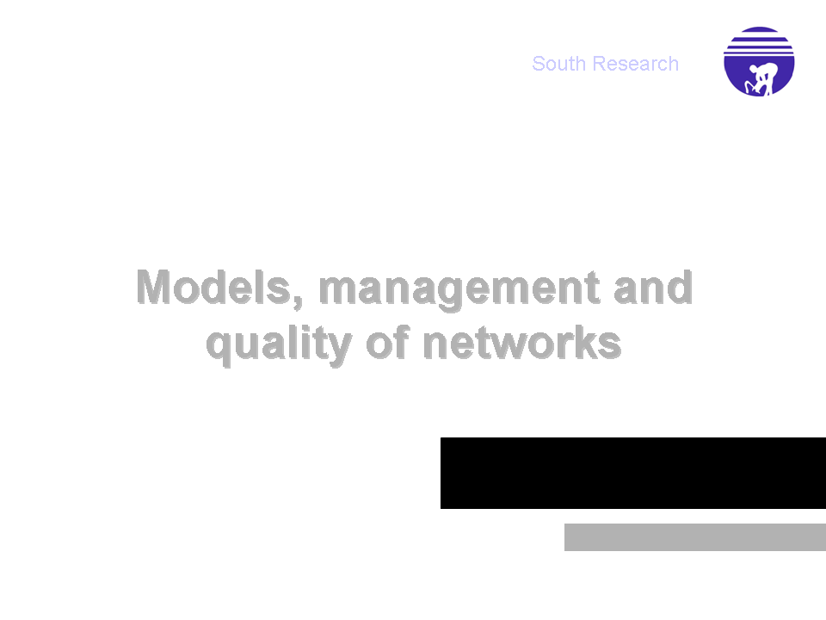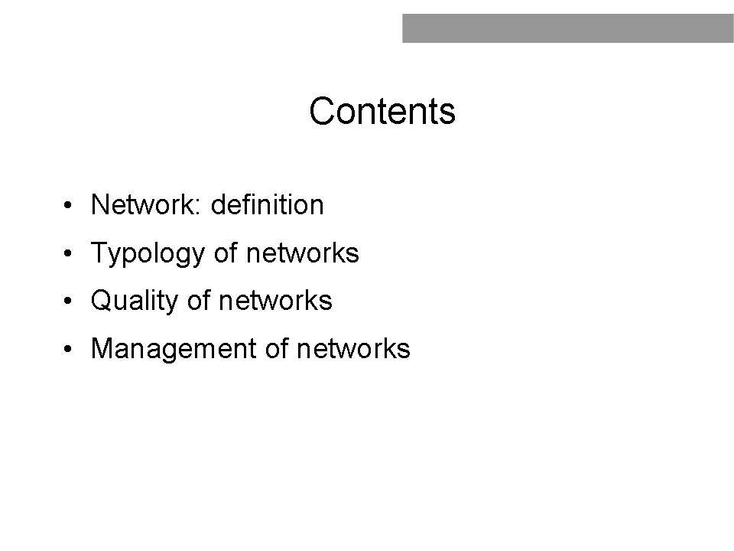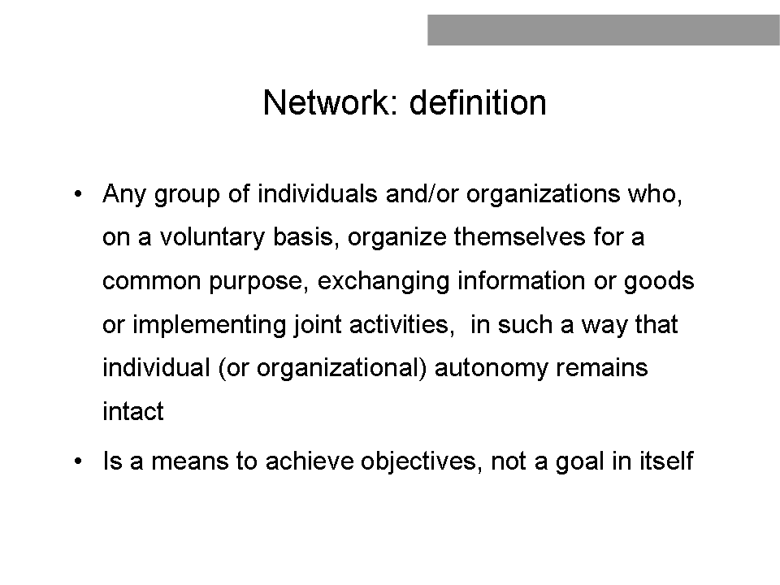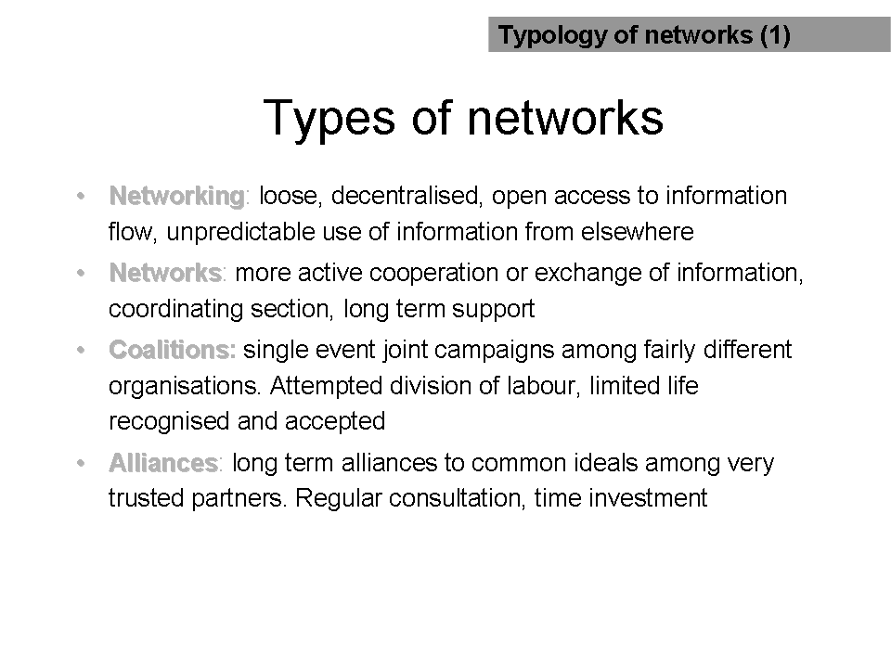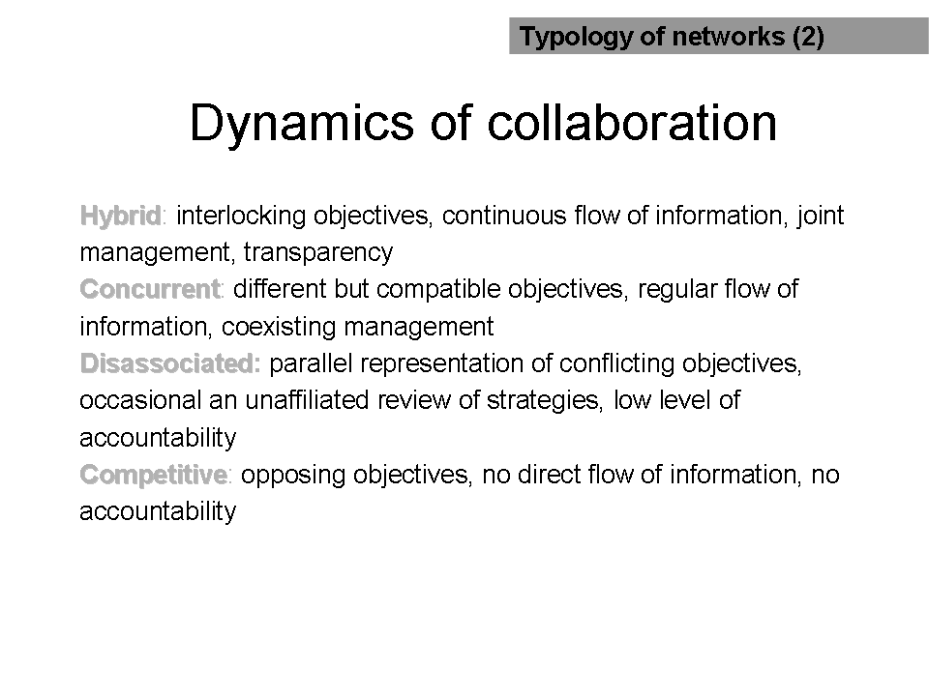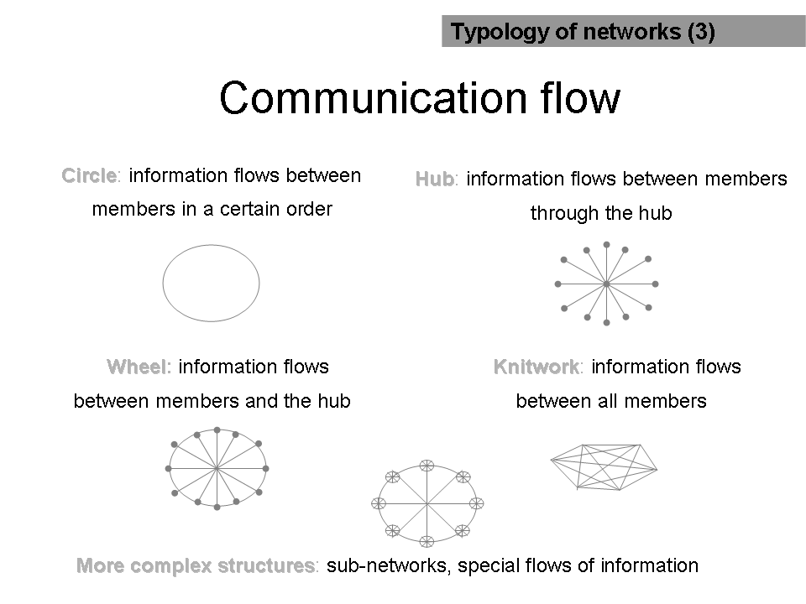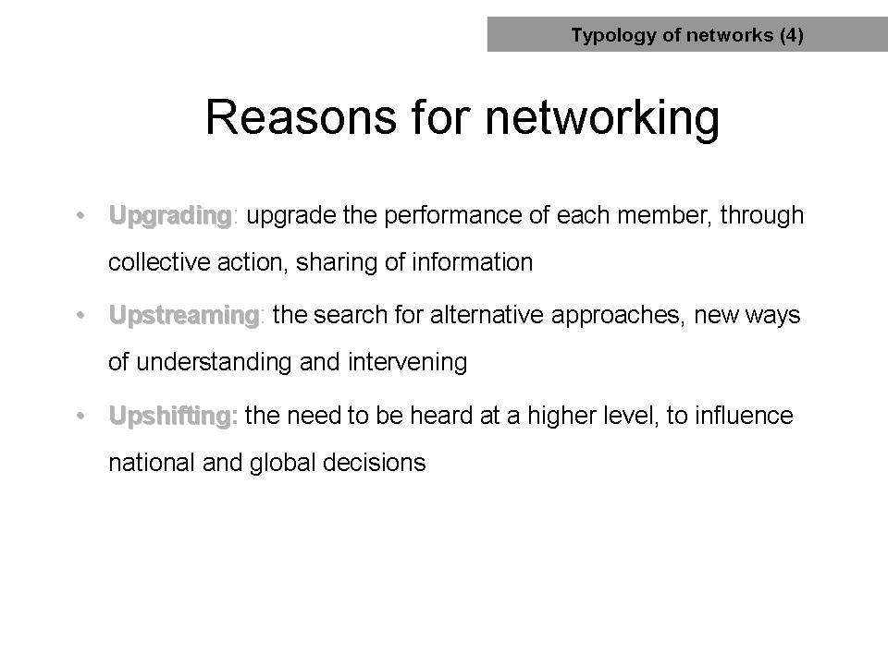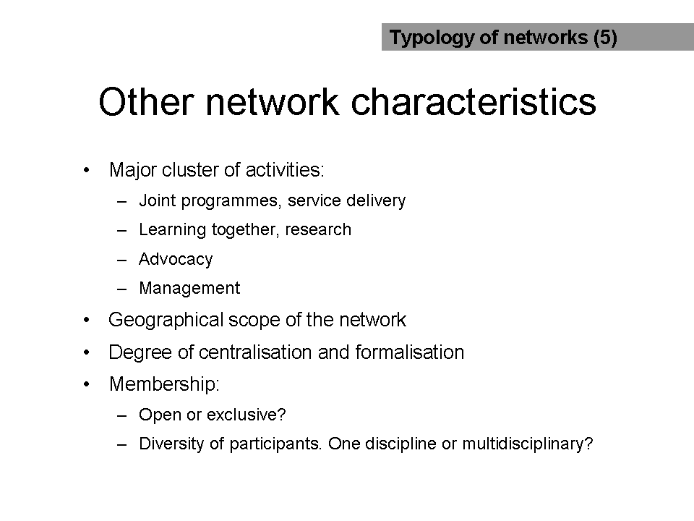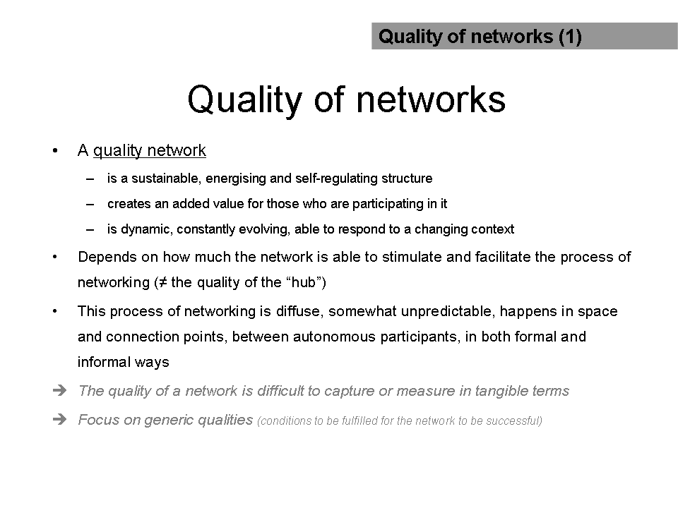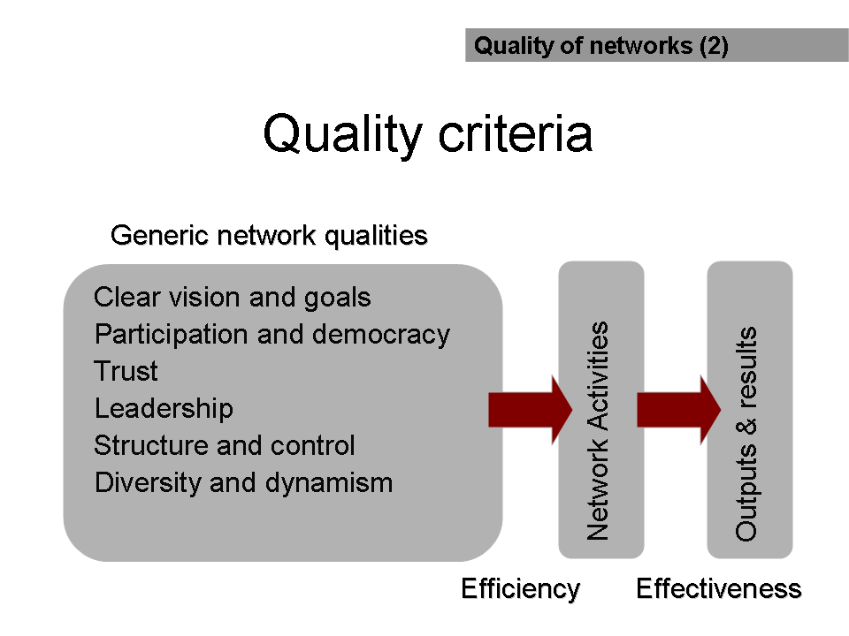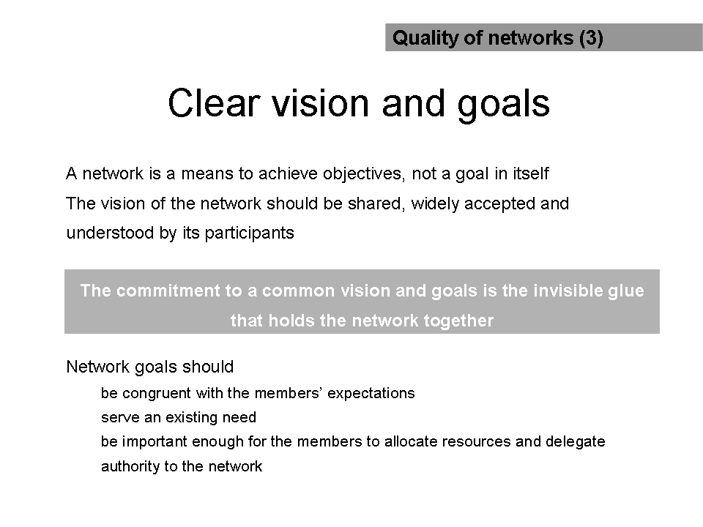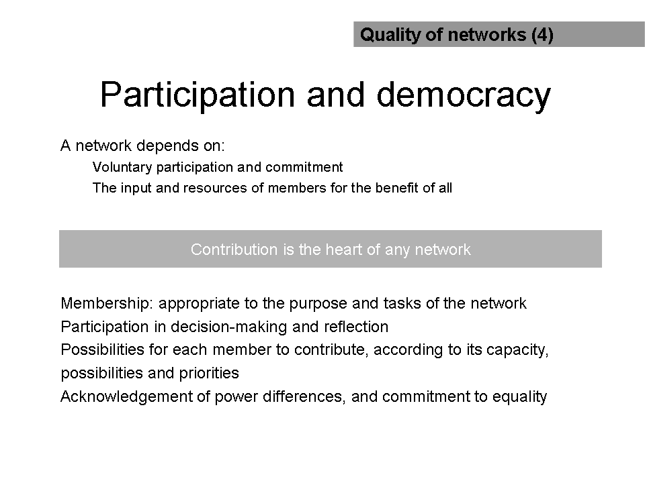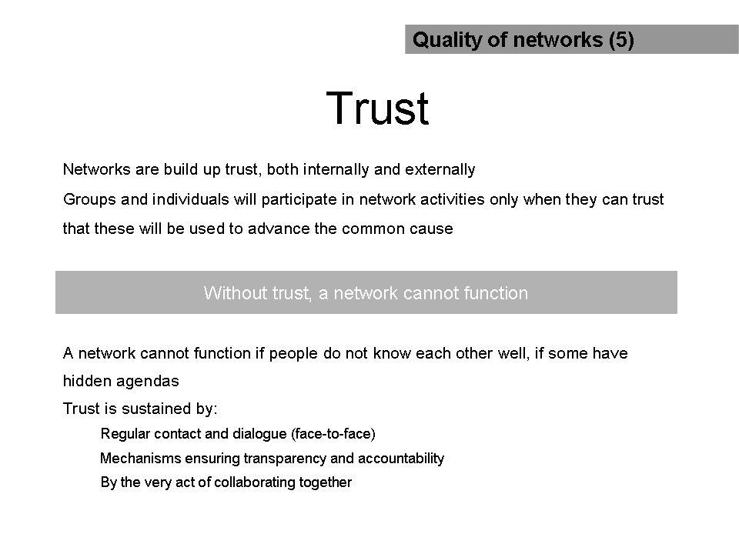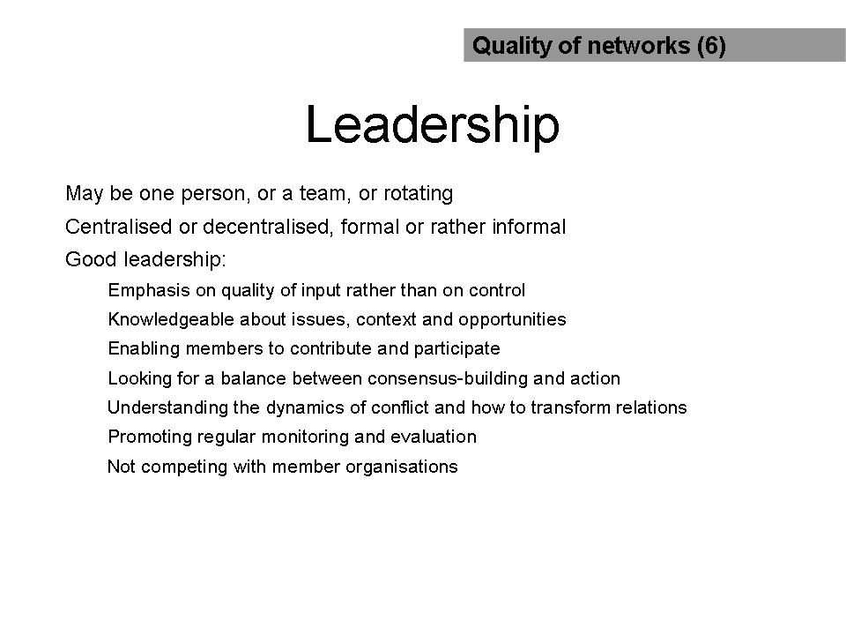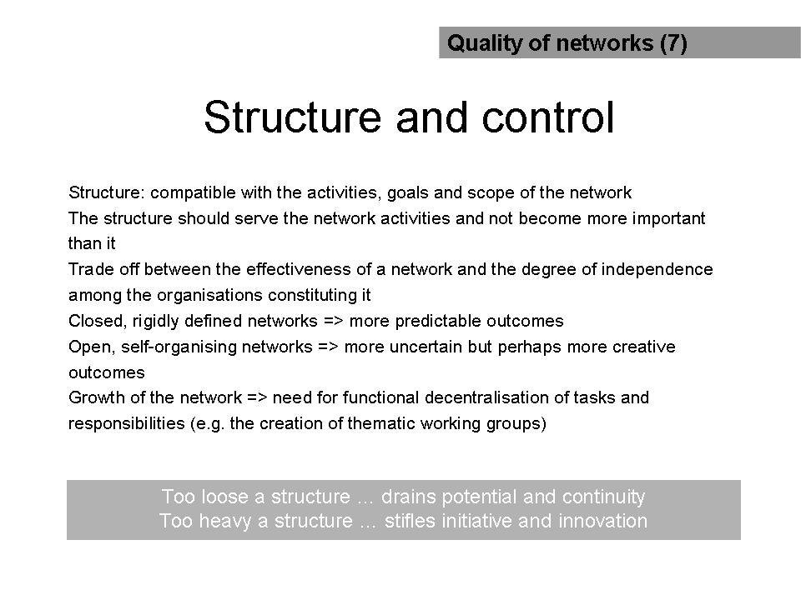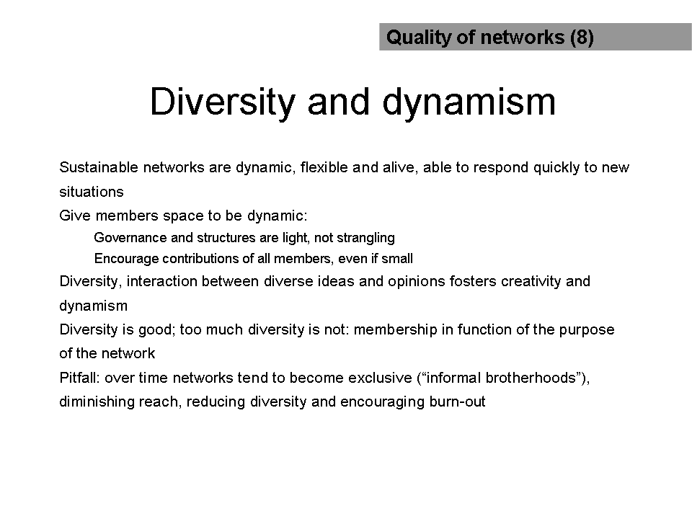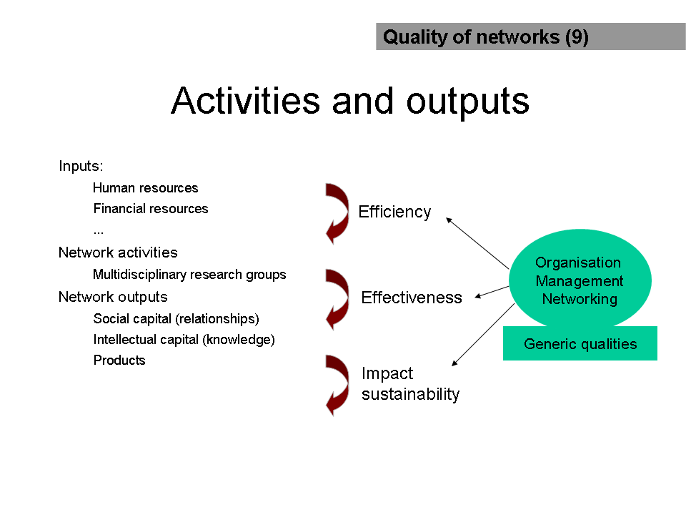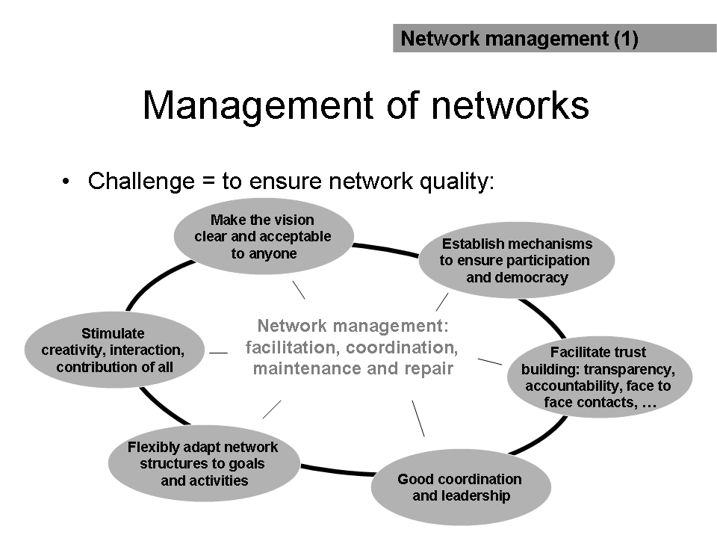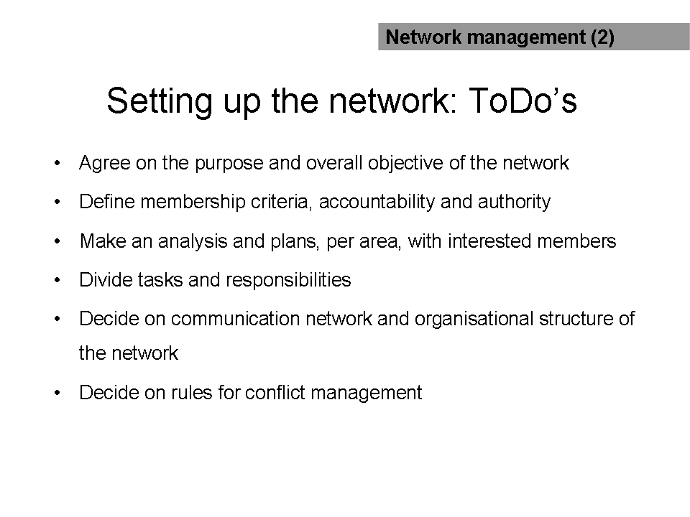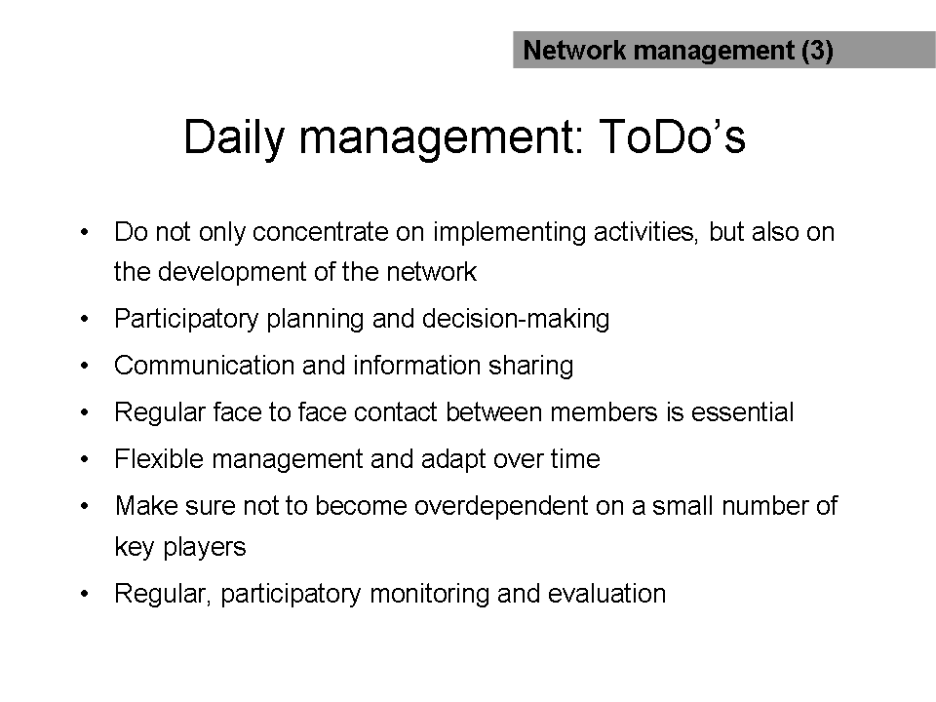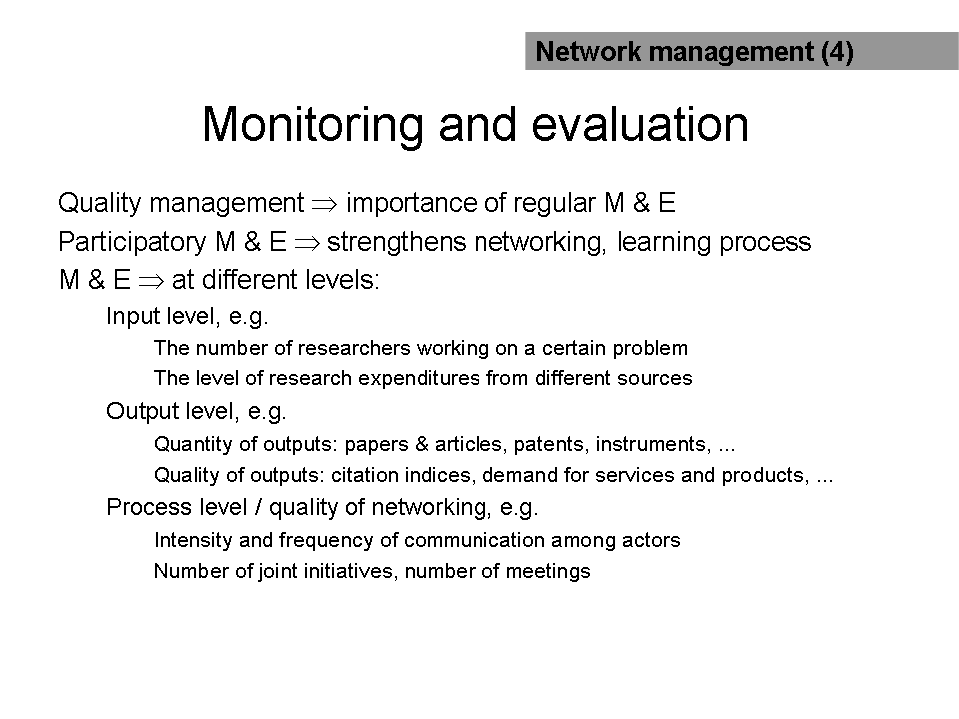
NOTES

SESSION III

European Microbicides Project - EMPRO

C. Kelly, GKT Dental Institute, King’s College London, SE1 9RT, R. Shattock, St. Georges Hospital Medical School, Cranmer Terrace, London SW17 0RE. Presentation by G. Vanham, Department of Microbiology, Unit of Virology, Institute of Tropical Medicine, Antwerp, Belgium

Introduction

The European Microbicides Project (EMPRO) is a consortium of 35 principal investigators from institutions including SMEs in Europe and Africa. EMPRO has been funded by the European Commission as part of the Sixth Framework Programme in the area of “Confronting the major communicable diseases liked to poverty”.

Aims and Objectives

EMPRO aims to develop a pipeline of microbicides and enter the first candidates of this pipeline into Phase I clinical trial. The candidates will be new topical microbicides with defined molecular targets that block the entry of HIV at mucosal sites, specifically the vagina. These microbicides are being developed for women in the third world in an attempt to give women greater choice and control over their health.

How

EMPRO consortium partners have a wide range of expertise from designing and analysing molecular structure, investigating mechanisms of HIV infection at mucosal sites, testing efficacy in animal models, methodology for large-scale production of microbicides and conduct of clinical trials. A selection of some of the novel technologies and approaches that EMPRO will be utilising to develop new microbicides include the glyconanocluster technology of Prof. Soledad Penades at CSIC in Spain, the anticalin technology of Prof. Arne Skerra in Munich and the nanobody technology of Ablynx NV in Belgium. Glyconanoparticles are multivalent systems, based on nanotechnology, that mimic the presentation of carbohydrate on the cellular surface and can be used therefore to block carbohydrate-protein interactions. Anticalins are a novel class of engineered binding proteins that are based on the small and robust lipocalin scaffold. Anticalins have hypervariable loops on top of a rigid framework, reminiscent of immunoglobulins, however in size they are marginally bigger than a single immunoglobulin domain and provide an alternative solution to antibodies for specific complex formation with various types of target molecules. The nanobodies developed by Ablynx consist of the smallest fully functional fragment of naturally occurring single-domain antibodies. They can exhibit inhibitory or antagonistic characteristics rather than just binding. Nanonbodies combine the advantages of conventional antibodies with the benefits of small-molecule drugs. The novel molecules and combinatorial peptide, polypeptide and oligosaccharide libraries generated by these and other technologies will be screened for inhibitors that are specific to selected targets. Microbicidal efficacy and effect of inhibitors on normal microbial flora will be tested in vitro. The most promising candidate microbicides will be formulated and tested in animal models. The development process for candidate microbicides will be target driven according to a selection criteria designed to fast track the most promising candidates and/or combination. Emphasis will be placed on development of compounds demonstrating synergistic activity with others from the programme or with first generation compounds developed by other groups that are further ahead in the development process. The EMPRO programme should provide a rational basis for the design of 2nd or 3rd generation microbicides.

Significance

EMPRO represents a major new collaborative effort within Europe to gather together a critical mass of experts to address the problem of HIV in the third world by developing novel microbicides. The EMPRO consortium brings together experts from a number of fields to ensure that the project has great depth and breadth in its approach and therefore the greatest chance of success in developing new therapies.

African Malaria Network promotes R & D across Africa

W L Kilama, AMANET, Dar-es-Salaam, Tanzania; S Jepsen, EMVI, Copenhagen, Denmark and S B Sirima, CNLP, Ouagadougou, Burkina Faso

Malaria is a leading cause of poverty and a major public health problem in sub-Saharan Africa; parasite and mosquito resistance are increasing, the malaria burden is worsening, and the Millennium Development Goal (MDG) of halting malaria and reversing its incidence cannot be attained unless new malaria control tools and strategies are introduced.

The African Malaria Network Trust (AMANET) which promotes capacity strengthening of malaria research institutions in Africa, invests in creating an enabling environment essential for African participation in the development of malaria control tools, currently focusing on malaria vaccine development. AMANET has therefore trained over 500 African researchers in aspects that ensure that Africans can function as Principal Investigators and leaders of malaria research institutions and that the field trials undertaken meet international scientific, ethical and Good Clinical Practice (GCP) standards.

AMANET also funds long-term professional training, provides essential research equipment, and improves infrastructure at beneficiary African trial sites selected for undertaking future malaria intervention trials. The zenith of AMANET achievements was the funding by AMANET of an all-African Phase 1b malaria vaccine trial in Burkina Faso; several more are planned, through collaboration with the European Malaria Vaccine Initiative (EMVI).

The development of malaria vaccines is a long and demanding process; the MDG of halting malaria by 2015 and beginning to reverse the incidence of malaria may as well coincide with the time when a malaria vaccine could be ready for public health use.

EUROLACTB:

European, Latin American and Caribbean tuberculosis network

J.-C. Palomino, Mycobacteriology Unit, Institute of Tropical Medicine, Antwerp, Belgium

EUROLACTB is a joint effort established by several European and Latin American researchers working in the field of tuberculosis with the purpose of collaboration in different areas of the disease and with especial emphasis in diagnostics and detection of drug resistance. There are currently twenty-eight participating institutions comprising research laboratories, reference centers and tuberculosis control programmes.

Among the main collaborative studies performed we can mention the improvement of microscopical procedures for direct diagnosis, the rapid detection of mycobacterial growth by a simplified micro-colony observation method, the rapid and reliable detection of multidrug (MDR) resistance by a colorimetric method and the validation of a rapid molecular tool for rifampicin resistance screening. Small pre-clinical trials have been initiated to validate these techniques and to assess their contribution and impact on disease control.

Several training and demonstration activities have already been organized and the use of modern tools of information and communication technology is constantly updated to ensure a wider dissemination of activities and establish new collaborations.

AARN: The African AIDS Research Network

S. Mboup, Laboratoire de Bactériologie Virologie (HALD), Dakar-University Hospital (CHU), Senegal

The AARN was born in January 1989 at ILe-Ife, Nigeria. It is an International non-profit and apolitical organization with diplomatic status and advantages related to that status. Members belong to different disciplines. It covers 22 western and central African countries. Membership is opened to all scientist of biomedical, social, people living with HIV/AIDS and behavioural sciences involved in AIDS research. The General Assembly is the sovereign body of the network. The Secretariat of the AARN which is the executive body is located in Dakar, Senegal.

AARN vision for 2003 – 2006. In response to that situation, the West and Central African AIDS Research Network (WCCARN), while consolidating acquired results and performances of the previous program will put emphasis on the following objectives. 1) Advocate for the strengthening WCCARN and its sustainability. Because, the key aspects of a basic infrastructure for conducting effective research and prevention include access to adequate funding and appropriate technology as well as sufficient managerial and administrative capacity to plan, execute, monitor and evaluate. 2) Increase the number of well-trained local researchers and provide other incentives for researchers to remain in their institutions. 3) Establish linkages between sub-Saharan institutions and international research centres and organizations. 4) Facilitate access to information and adequately disseminate findings and research results widely access the continent. 5) Utilize existing local resources to the fullest extent possible, since local expertise may also strengthen local institution and create opportunities for talented researchers in sub-Saharan. 6) Develop programs of inter-country and multidisciplinary researches with National Networks.

Drugs for Neglected Diseases Initiative

S. L. Croft, PhD, DNDi, 1 Place St Gervais, CH-1201Geneva, Switzerland

In many parts of the world patients continue to suffer from neglected diseases such as tuberculosis, malaria, leishmaniasis, human African trypanosomiasis (sleeping sickness or HAT), and Chagas disease. Many of the currently used drugs are compromised by poor efficacy, toxicity, long courses of treatment, parenteral administration and resistance. From 1975 to 1999 of the 1393 new drugs marketed only 13, or a mere one per cent, were for tropical diseases. The Drugs for Neglected Diseases Initiative (DNDi) is one of several not-for-profit organizations that aims to change this situation picture and ensure that new drugs become available for the treatment of these diseases within the next decade. DNDi intends to focus its current portfolio of discovery and development projects on the most neglected diseases, HAT, leishmaniasis, and Chagas disease.

DNDi was established in 2003 in Geneva by seven founding partners that have extensive experience in the field of public health and research: MSF, WHO/TDR, Institut Pasteur, the Kenya Medical Research Institute (KEMRI), the Oswaldo Cruz Foundation, the Indian Council for Medical Research (ICMR) and the Malaysian Ministry of Health. DNDi will initiate, coordinate and manage drug discovery and development projects in collaboration with the international research community, the public sector, the pharmaceutical industry, and other relevant partners. This will follow a virtual not-for-profit, collaborative model of drug development, used also by MMV and GA TB, as well as highlighting the importance of public responsibility in providing equitable access to these tools.

DNDi currently has a portfolio of 9 projects, including four close to clinical trial for leishmaniasis, trypanosomiasis and malaria, one in the stage of pre-clinical development and four discovery projects. Projects come from both a public call for letters of interest, from which a few are chosen for full applications, and through proactive initiatives. All projects are reviewed by a Scientific Advisory Committee that meets twice per year. In 2004, DNDi received 96 letters of interest to a call of which 4-5 will be funded. It is expected that DNDi will be supporting fifteen R & D projects by 2005.

Intra-EU programmes and their implication for developing countries: the example of TropNetEurope

T. Jelinek, Chairman, TropNetEurope, University of Berlin, Institute for Tropical Medicine, Germany

Surveillance of infectious diseases has a long history. Most systems are based on national notification schemes that work diagnosis-oriented. These conventional surveillance programmes largely depend on public health departments and laboratories. Direct patient contact of the person doing the reporting is an exception. National systems of infectious diseases surveillance generally focus on complete coverage. The potential advantage of this approach is that no cases are overlooked. In reality, however, compliance with notification regulations is very limited. Estimated coverage rates at or below 50% are rather the norm than the exception. The lack of motivation among those requested by law to report is one of the major stumbling points for traditional surveillance systems.

Increasing awareness of emerging infectious diseases has fostered the creation of new surveillance networks. In addition to systems aiming at complete coverage, an increasing number of national and international sentinel networks are being established. The use of sentinel sites has the disadvantage that complete coverage cannot be achieved. However, a prudent selection can ensure that a sentinel network produces representative information. In general, sentinel networks consist of voluntary members that are more focussed on surveillance. Thus, information flow is often faster than in systems that are aiming at complete coverage.

Clinical sentinel networks represent a new concept that adds information to conventional surveillance programs. The clear advantage of these systems is that the persons reporting the requested data have seen the patients themselves and can relay first-hand information. An example of such a network is the European Network on Imported Infectious Disease Surveillance (TropNetEurop). Although focussing on diagnosis-based reporting on the forefront, TropNetEurop is strongly encouraging reporting of unexpected events and syndromes. The network has been very successful in detecting outbreaks of emerging diseases in the past and has thus proven its value as an additional surveillance tool (www.tropnet.net).

TropNetEurop demonstrated repeatedly that networking within the EU can have direct implications for developing countries. Constant screening of imported diseases and pathogen isolates is enabling TropNetEurop to establish screening tools for emerging diseases and drug resistance in endemic areas. As future outlook, it should be hoped that traditional surveillance systems and recently introduced networks will be able to cooperate more fully. All systems have strengths and weaknesses and can gain from information provided by other networks. Thus, the linkage of existing networks in order to avoid duplication of work and to fully exploit the information potential of all combined systems should be targeted.

EDCTP – the first year

B. Lindtjørn, Executive Director, EDCTP, Den Haag, The Netherlands
For more information: EDCTP Secretariat. Tel: +31 (0)70-344 0880
Email: info@edctp.org www.edctp.org

What is the EDCTP?

The European and Developing Countries Clinical Trials Partnership (EDCTP) was established by EU Member States and Norway as a genuine and sustained partnership with the developing countries (DCs). The EDCTP is the first initiative within the so-called ´Article 169 procedure´ of the Treaty of the European Union, enabling Member States to streamline their national research programmes, with support from the European Commission.

The mission of the EDCTP is to accelerate the development of new clinical interventions to fight HIV/AIDS, malaria and tuberculosis in the DCs, particularly sub-Saharan Africa, and to improve generally the quality of research in relation to these diseases.

The activities of EDCTP include:

- stepping up cooperation and networking of European National Programmes (NPs) accelerating clinical trials of new and improved existing products, in particular drugs and vaccines, in the DCs;
- ensuring that research effectively addresses the needs and priorities of DCs;
- helping to develop and strengthen capacities in the DCs, including the promotion of technology transfer;
- encouraging the participation of the private sector;
- mobilizing additional funds to fight these diseases.

The general aim is to establish a sustained partnership between Europe and DCs in the fight against the three diseases to ensure that the programme meets the needs of DCs. More specifically, the activities of the EDCTP will be based on the following pillars and aimed at achieving the following objectives:

- Knowledge
  - generated by conducting high quality clinical trials;
  - disseminated to be widely available and freely accessible;
  - designed to inform policy decision.

- Sustainability
  - capacity - transfer empowerment to the development world by increasing generally the quality of research and building leadership in health research;
  - ownership – full involvement and contribution of stakeholders in establishing priorities and conducting research;
  - partnership – optimise synergies between research programmes of stakeholders and partner organisations.

EDCTP’s objectives are reached through the execution of the Joint Programme, comprising of the NPs of the participating European states, the institutional and/or national programmes in the DCs, the EDCTP-funded activities and co-funded activities in partnerships with other initiatives and/or industry.

Need of networking of National Programmes

European states are already undertaking nationally funded research and development programmes and other activities aimed at developing new clinical interventions as well as at training and capacity building in DCs. The EDCTP initiative believes that European funding in this research area can be more effective, and added value can be derived, by increased cooperation and coordination.

The objective of coordination of and cooperation among national programmes is to combine the national activities in a European approach to accelerate the development of clinical interventions against HIV/Aids, malaria, and tuberculosis.

Expected outcomes:

- increased coordination of the nationally funded activities that are executed in Africa (by European-African partnerships);
- more efficient and effective spending of European clinical trial, capacity building and human resources;
- increased scientific quality through a more competitive international research area.

South-South networking and coordination

The participating Member States recognize that the objectives of their NPs, and therefore the Joint Programme as implemented through the EDCTP cannot be achieved without the full participation of the DCs. Therefore the major objectives of the Joint Programme, under this heading will be to:

- improve the networking between scientists, clinical trials sites, policy makers and Governments from European and DCs;
- identify and secure the support of the scientific and clinical communities in the DCs;
- ensure that the EDCTP programme has full political support by Governments and decision makers in the DCs.

Support of clinical trials

Overarching funding principles of the EDCTP decision making and funding process:

- are guided by health needs and scientific opportunities;
- will fund clinical trials and clinical trial capacities for preventing or treating HIV/AIDS, TB and malaria;
- selection based on scientific excellence and public health relevance;
- favour networking and co-ordination;
- priority given to studies in Sub-Saharan Africa.

Need for Capacity Building

Insufficient local capacity, both in terms of infrastructure and personnel, often constitutes a bottleneck in the development of new interventions. Measures to improve the capacities and capabilities to conduct clinical trial research are therefore essential to enable groups in DCs to assess independently the interventions that they need. The EDCTP has therefore included capacity building as a specific objective in its Joint Programme.

The general objectives for capacity building are:

- general strengthening of the clinical trial research capacity of (individual or networks of) clinical trial research sites;
- training of DC clinical trial research personnel, both in Europe and in DCs.

The organisation of EDCTP

EDCTP’s governance model is based on two main pillars:

- The Partnership structures constitute EDCTP’s strategic planning arm providing the scientific and regional expertise that is necessary for steering the EDCTP programme. It comprises the Partnership Board - the main strategic body, the European Network of National Programmes (ENNP) and the Developing Countries Coordinating Committee (DCCC);
- The EDCTP-EEIG provides the legal, financial and operational structures of EDCTP needed to receive, dispense, and account for funds, and execute the strategies and actions recommended by the PB. It has two organs: the EEIG Assembly, the final decision-making authority in which all participating European states are officially represented, and the Secretariat, the organisation’s day-to-day management body headed by an Executive Director.

Bottlenecks for new interventions in health care

F. Matthys, Department of Public Health, Unit of Epidemiology, Institute of Tropical Medicine, Antwerp, Belgium – fmatthys@itg.be

If EDCTP wants to have an impact on population health, its products, new interventions in AIDS, TB and malaria, should be appropriate for Developing Countries (DCs) and ultimately reach those who are in need. Priority setting for clinical research should be guided by the likelihood of products being effectively introduced and implemented in DC’s health services. This study invited African key-informants to identify existing obstacles to innovation in the health services in their country, because these obstacles might also prevent the effective introduction of new interventions developed with EDCTP support.

DC experts in Sub-Saharan Africa were consulted twice. In a first round, participants identified existing obstacles. In a second round, recommendations were formulated for the selection of future research projects, as well as for the effective implementation of health interventions in DCs.

Respondents (n=47) in the first round were unanimous about the urgent need to get health as a priority on the political agenda of the governments of their countries. They saw it as a conditio sine qua non to achieve sufficient or at least better budget allocations to implement efficiently coherent health policies.

Inadequate policy setting and weakly formulated strategies were identified as important obstacles for the implementation of interventions for all three diseases (be it for different reasons). For instance the complexity of HIV/AIDS requires a variety of interventions for prevention, diagnosis and treatment, which need to be better co-ordinated, both within the health sector as well as inter-sector.
The high cost of newly developed effective drugs delays their adoption in control policies of developing countries. The cost of anti-retroviral drugs has hampered for many years the possibility to even consider ARV therapy for HIV/AIDS patients. Effective antimalarial drugs needed in case of resistance against chloroquin are not considered in national control policies because of their cost. The high cost of insecticide treated bed-nets is also a serious obstacle for the implementation of bed-nets for malaria control.
But other bottlenecks exist which weaken national policy formulation: poor drug regulation induces supply problems in antimalarial drugs, as well as use of counterfeit drugs. The non-involvement of the private sector in the control of tuberculosis was identified as a shortcoming in the policy setting. But also the centralisation of treatment of tuberculosis leads to non-accessibility of care for patients especially in rural areas.

At implementation level, problems are mainly due to lack of financial resources as the result of the general under funding of the health sector. The lack of appropriate training of health staff however contributes heavily to the problem. Capacity building is a major necessity for all three diseases, though overwhelming in the field of HIV/AIDS.

Poor drug procurement and management, quantification of drug needs, and distribution leave health services with frequent stock ruptures.
Laboratory services seem largely neglected in the health sector. Lack of basic laboratory services, lack of trained laboratory personnel, supply and quality control problems are important bottlenecks for the control of the three diseases. This seriously hampers the diagnosis and follow-up of patients. The current laboratory techniques for follow up of patients under ARV therapy are too complex and too expensive for most countries, research in more cost-effective techniques is needed. Better tools for the diagnosis of tuberculosis are urgently needed.

Geographical and financial accessibility of health services is limited, especially in the rural areas of most countries. This is a problem for all three diseases but more so for the more specialised services that are needed for HIV/AIDS care and to a lesser extent in the case of tuberculosis and complicated malaria.

Last but not least, socio-cultural factors constitute important obstacles for uptake of new interventions. Stigma and denial of HIV/AIDS, and to a lesser extent of tuberculosis, impedes the uptake of Voluntary Counselling and Testing, which is the entry point for preventive actions such as e.g. prevention of mother to child transmission. The need for effective education, information and communication is still huge in all countries for all three diseases. This needs to be adapted to the specific social-cultural setting of the populations. Enhancing the communication skills of health staff involved in care and of staff involved in preventive actions such as IEC continues to be a necessity.

In the second round of consultations, panellists identified criteria for the selection of projects by EDCTP. Those criteria of safety, efficacy and ethics were generally in line with GCP standards and ethical guidelines for clinical trials in developing countries. However, the panellists raised serious concerns about the future availability and especially the affordability of the products supported by EDCTP. The end product must be affordable for the poor population and the health care systems in the developing countries. The end product must also be adapted to the technical conditions of the developing countries. The projects must contribute to capacity building in the developing countries. Also, the need to involve African health authorities, and not only the African research community, in discussions on R&D was stressed by several panellists.

All panellists agreed on the need to develop new, be it preventive, diagnostic or therapeutic tools for all three diseases, and supported the philosophy of EDCTP. However, they stressed the importance of health systems and health policy research in this matter. Existing or future health technology for disease control must be adapted and/or implemented in developing countries. Support is badly needed to develop policies and strategies that are adapted to the resource-poor environment of developing countries and the local social-cultural context. But research is also necessary on more general issues such as the organisation of health services in order to provide easy access to the population.

If effective “interventions” resulting from the EDCTP project are to be successfully implemented in developing countries, operational research, health system research, advocacy and capacity building on how to implement these in the local context are needed. Additional funding will be necessary in order to strengthen the health services
that need to realise the activities.

NOTES

SESSION IV

Health system research in INCO-DEV: lessons from the
past for the future

G. Tomson, Karolinska Institute, Stockholm, Sweden and EU/INCO Health Systems Expert Team

An external evaluation

Health systems

Health systems have been undergoing significant changes in recent years yet these changes are often not based on robust evidence.
A greater understanding of how health systems do, and do not, function is a fundamental prerequisite to improving health in developing countries. Policies to scale up add a further dimension to the need to understand health systems.
Global factors are increasingly influencing the functioning of the health sector and require policy attention.

Health systems research (HSR)

Health system research is a relatively new field of research which examines the interactions between functions, elements and actors in the health system. There have been a number of initiatives in recent years to strengthen HSR, yet there remain important challenges.

There is a need for increased levels of research funding for HSR.

Clear and transparent processes for identifying and prioritising health system issues for research are required.

An appropriate balance between applied and theoretical research and also between mainstream and risk-taking HSR is needed. Adequate provision for longer-term and conceptual and methodological research is also required. The relative youth and complexity of HSR suggests the need for continued attention to strengthening of its methods basis.

Greater research leadership and ownership by developing country institutions is needed. This requires investment in capacity-building activities.

Urgent attention is needed to find ways of addressing the Know-Do gap including seeking early interest in the research by policy-makers and identifying ways of sharing research findings appropriately through Getting Research into Policy and Practice (GRIPP).

European Union policies

Health systems in the European Union (EU) are based on values including solidarity and universal access to services, which provide a basis for EU external action on health.

European States are diverse and include a number sharing similar problems and health system characteristics with developing countries. Important insights in both directions can be gained especially from analysis of health policies, pharmaceutical policies, decentralisation and the impact of globalisation on health systems.

European Commission (EC) policies support international health systems research. However, specific support will be required to ensure that this is not compromised by narrowly oriented research needs and policy priorities addressing only specific problems.

The challenge facing EU policies in development and health is to ensure that priorities are not compromised on the basis of increasing focus on internal markets and policies on trade and security. This challenge of coherence and capacity warrants more, rather than less, emphasis on analytical skills and knowledge on health systems within the EU.

European Commission support to health systems research in developing countries

The EC has, over the 20 years of HSR support in INCO-DEV, made a significant contribution to funding HSR and building the capacity of institutions and individuals in both Europe and developing countries and has contributed to the creation of solid partnerships.

There are, however, areas in which such support could be made more effective through improved prioritisation and administrative procedures.

There is potential for further HSR learning and capacity development and transfer of existing knowledge through equitable North-South, South-South and South-North partnerships which should be further encouraged.

Capacities, both for research and for using research findings particularly in developing countries, need further strengthening requiring greater investment by the EC in this area.

Inevitable tensions between competing priorities for funding remain and this reflects a lack of a current clear prioritisation mechanism.

Further efforts are needed to promote Getting Research into Policy and Practice (GRIPP) in the INCO-DEV programme. This suggests the need for more understanding of the constraints and resultant strategies to overcome the Know-Do gap.

The Mexico summit provides an important opportunity for exploration of the general issues explored in this report and their interrelationships as part of a health system research system.

Recommendations

General recommendations
- The research community and other key actors should engage more closely with funding agencies and policy-makers to convince them of the benefits of increased investment in HSR and capacity-building and help them to understand the context within which research institutions operate.
- International agencies including the EC must urgently and significantly scale up their funding for HSR.
- Support should be given by international agencies, including the EC, to the development and maintenance of Regional Health System Observatories to collect and disseminate regionally based evidence.

Recommendations to the EC
- The EC should develop a more structured and open approach to prioritising health systems research calls involving both the research community and key southern stakeholders. This should include specific ring-fenced funding for methods development in HSR and support to conceptual and long-term research alongside support for medium-term research and capacity development.
- The EC should continue to support capacity-building of institutions both through INCO-DEV and development funds in both the South and the North. This should include:
- a requirement that capacity-building is seen as a key component of every project
- capacity-building support for policy-makers to use and interpret research findings.
- The EC should, in INCO-DEV, give greater emphasis to GRIPP, through:
- commissioning work to understand better the process, by sharing experiences in this field, or by requiring specific attention to it in project design
- enhancing the capacity of policy-makers to use research findings
- widening the current criterion of ‘dissemination’ to ‘GRIPP’
- fostering national partnerships involving researchers, practitioners and policy makers as it has fostered international research partnerships
- involvement of key parties in the identification of research topics and in the development of the research
- greater attention and investment in dissemination methods
- links to development resources to implement findings
- The EC should build on the values of universal access and solidarity in European health systems through:
- encouraging comparative study (North-South, South-South and South-North directions) of health systems based on similar values
- explicit extension of these values to the global stage through increased support for developing country health systems
- The EC must seek ways of strengthening collaboration between INCO-DEV and AIDCO to ensure cost-effective use of research data and GRIPP in the EC context. Both Directorates need to strengthen their analytical capacity and develop linkages which will also serve as an example of good practice for national health systems.
- The EC INCO-DEV needs to find ways for optimal coordination with other key actors at the global and national levels. The Mexico summit meeting is a platform for strengthening that, capitalising on the presence of high level policy-makers enabling instant feedback and recommendations.
- The EC should use a variety of instruments to support HSR, some allowing for long-term funding of larger endeavours, but others more appropriate for exploratory, innovative or more reactive research, which may thrive better in smaller projects, with shorter time-frames and with simplified approval mechanisms.
- The EC should simplify its application (including web pages) and project management and reporting procedures, making them more transparent and streamlined, and strengthening its support to, and training for, administrative coordinators. It should develop further its electronic database as a means of monitoring research projects.
- The EC should, in the interest of fostering equitable participation, encourage the submission of more proposals from co-ordinators in Southern institutions and should consider improving the instruments to create national networks through platforms and the possibility of granting ‘seed money’ to allow prospective research partners to meet to compile a full proposal.
- The EC should give greater encouragement to the use by researchers of pre-proposal checks and feedback on outline proposals.
- The EC should support a regular forum of EC funded researchers, policy- makers and practitioners to share ideas, methodologies, and research priority concerns and to provide a means of dialogue with the EC on issues related to project management. Other forms of information sharing such as web-sites could also be considered.

Health policy and research – Viewpoint of the
Cambodian Ministry of Health

C. V. Mean, Director of the National Centre for HIV AIDS, Ministry of Health, Phnom Penh, Cambodia

Research agencies and development

C. Krijger, Senior Staff Member Natural and Medical Sciences, NWO, Den Haag,
The Netherlands - krijger@nwo.nl

Experiences of the Netherlands Organisation for Scientific Research, Foundation for the Advancement of Tropical Research (NWO-WOTRO).

Knowledge is important for guiding social and technological change, for making informed, evidence-based decisions, and for improving the livelihoods and the quality of life of people in the developing countries. National research funding agencies can play a significant role in mobilising scientific knowledge and innovations for development questions, even though they manage only a minor part of the total research funds available. This presentation will highlight some experiences of the Netherlands Foundation for Tropical Research in encouraging and supporting scientific (health) research in tropical and developing countries. Furthermore, some ideas will be put forward on enhanced European cooperation in funding research for development.

WOTRO distinguishes seven pillars that support the realisation of it mission: enhancing high quality scientific research in tropical regions and developing countries with emphasis on societal relevance. These are: scientific excellence; multi-disciplinarity; scientific capacity building; organisation of demand and priorities; networking and institutional sustainability; evaluation and knowledge sharing; leverage and bridging funding gaps. WOTRO’s portfolio of activities and funding instruments is continuously adapted to new developments, e.g. in science or policy, national and international. For example, the creation of the European and Developing Countries Clinical Trials Partnership (EDCTP) has recently prompted the development of a new national programme for poverty related diseases: the Netherlands-African Partnership for Capacity Development and Clinical Interventions (NACCAP) aiming to strengthen research capacity through joint research activities in Africa.

International cooperation and coordination among national funding agencies can have many benefits: increased joint effectiveness and impact through joint programming and coordination of activities in the developing countries; more efficient spending of combined resources, avoidance of duplication; creation of critical mass and combing efforts to address highly complex research questions. International coordination of funding facilitates the cooperation with international development policy and development organisations. Furthermore, international benchmarking and sharing of best practices can lead to improvement of and streamlining in funding procedures, e.g. in how to combine scientific excellence and development relevance in funded research. Last, but certainly not least, cooperation will increase flexibility in North-South partnerships in research funded by multiple agencies. Given recent developments, European coordination of funding agencies may even yield substantial additional research funding by the EU (ERA-net+).

European academia and international health policies

D. de Savigny, Swiss Tropical Institute Basel and Alliance for Health Policy and Health Systems Research, Geneva, Switzerland

This presentation maps out some of the features that exemplify recent initiatives at South-North networking. Different models exist: networks, alliances, consortia, initiatives, observatories, just to mention the most common ones. These are becoming, more than ever, better positioned to influence policy.

European and other academia are linked to these processes. They have specific entry points and face their own challenges. The essential ingredients to make it work have to be available.

New pathways have to be explored, particularly on knowledge management and on brokering for influencing policy.

NGO’s & international health policy

A rational Europe, a rational world

Lessons from the TRIPS Agreement

S. Gombe, Policy Advisor, Health Action International, The Netherlands

Background
HAI works towards a world where all people, especially the poor and disadvantaged are able to exercise their human right to health. This requires equitable access to affordable quality health care and essential medicines. HAI and its global partners recognize that poverty and social injustice are the greatest barriers to health and sustainable development. Partners are working for just societies where people can participate equitably in all decision making that affects their health and well being, including the allocation of resources.
HAI’s strength is to enable consumers, health care providers, public interest NGOs and policy makers to collaborate based on mutual interests and common positions to advocate for policy changes and improved health for all. Partners work together to respond rapidly to priority issues by sharing information and expertise. Collaboration creates a broad base of support and ensures that the concerns of diverse communities are communicated at local, regional and international levels.
For many years the focus of HAI’s advocacy work was the promotion of the Essential Medicines concept of the WHO. Eventually it became clear that developments in other areas of government - particularly in trade policy - threatened to torpedo many of the gains made in health systems improvement through rational policy. In the early 1990s, HAI was mobilised to work in collaboration with Médecins sans Frontières, The Consumer Project on Technology, OXFAM International, The Third World Network and many other partners, to lobby all governments and intergovernmental bodies to enact trade and pharmaceuticals policies that do not impede the right to health. The Doha Declaration on TRIPS and Public Health marked a partial victory on the part of many networks in this regard, and marked a sea change in the relationship between international NGOs and governments of developed and developing countries.
The presentation here charts the evolution of HAI’s efforts in international health policy following our advocacy on a small number of paragraphs in the TRIPS Agreement to sustained interaction with several of the Directorates-General of the European Union, the UN system and regional intergovernmental bodies, all the way to the support for a new Global Framework for Research and Development.

Networking for monitoring antimalarial treatment:
EANMAT experience

T.K. Mutabingwa, Chairman EANMAT, Muheza-Tanga, Tanzania

The East African Network for Monitoring Antimalarial Treatment (EANMAT) was conceived in 1997 using a bottom-up approach, in response to Eastern Africa’s growing need for reliable information on the sensitivity of malaria parasites to antimalarial drugs. Its main goal is to generate and provide high quality data /information on antimalarial treatment efficacy to policy makers in the sub-region. It has achieved this by setting up and supporting sentinel sites based in health facilities, disseminating information, organising sub-regional and International policy debates and supporting operational research.

EANMAT has now firmly established itself as a vital force in antimalarial drug policy review and development in Eastern Africa and beyond. Five of six EANMAT-served countries have either changed to or adopted an antimalarial policy of artemisinin containing compounds (ACT), as globally recommended. It has been used as a model for the design and operation of similar networks in West Africa (WANMAT I & II), Horn of Africa (HANMAT) and in South America RAVREDA). The Network has good working relations with other international health agencies such as WHO (Africa Region and headquarters in Geneva) and the Roll Back Malaria (RBM) Partnership. The Department for International Development (DFID) of the British Government has been the main funding agency of the Network. Other financial assistance was obtained from the Danish International Development Agency (DANIDA), Institute of Tropical Medicine in Antwerp (DGDC/ITM) and WHO-Africa Region (WHO/AFRO).

The Network has met considerable challenges in reaching its current position. These include: ensuring full involvement of all stakeholders, representing interests of all countries, ensuring accountability, optimal utility of the limited resources and expertise within the Network, effective and timely communication. Various approach models have been used to overcome the challenges and sharing these with all newly formed Networks or Networks in the making would facilitate networking the Networks. EANMAT will happily share all its experiences.

The Supra-national Reference Laboratory (SRL)

Network for tuberculosis

A. Van Deun, Department of Microbiology, Unit of Mycology, Institute of Tropical Medicine, Antwerp, Belgium – avdeun@itg.be

The network was created in 1994, on impulse of the World Health Organization (WHO) and the International Union against Tuberculosis and Lung Disease (IUATLD). It is meant to support the Global TB Drug Resistance Surveillance Project launched at that time by both organizations. Its primary aim is standardization and quality assurance of drug susceptibility testing (DST) of Mycobacterium tuberculosis (MTB).

Over the years, the network has counted between 16 and 25 laboratories. The “inner core” consists mainly of European reference laboratories, with only two low-income country members. So far, membership has not been well regulated. An attempt at admitting more labs located in low- and middle-income countries is underway. On the other hand, it would be justified to subject also the current members of the network to a certification procedure, based not only on quality performance in DST, but also on activities outside the own borders.

Organization of the annual rounds of quality assurance is undertaken by a coordinating laboratory, with financial support of WHO. Since 1999, this is the Mycobacteriology Unit at the Institute of Tropical Medicine in Antwerp, Belgium. A panel of 20-30 strains of M. tuberculosis is chosen and distributed by the coordinating lab, to represent about fifty percent of resistance to each of the four main drugs (isoniazid, rifampicin, streptomycin and ethambutol), in various combinations. Evaluation is based on the “judicial result”, i.e. the result reported by the majority of participants. The other SRL are then supposed to organize their own regional rounds of quality assurance, using the same strains, and so on up to national level. Unfortunately, no funding is available for these regional or national rounds, and they may have remained exceptional.

The initiative has succeeded in better standardization of first-line DST of tuberculosis, mainly during the first years. Several variations of technique were found to be at the origin of discordant results. On the other hand, it was recognized that, besides proportion method on Löwenstein-Jensen medium, also other widely adopted methods can yield the same results, and consequently these were included among the recommended methods for resistance surveillance. Furthermore, a service of quality assurance by way of re-testing of local routine strains has regularly been offered as support with national drug resistance surveys. Some SRL have also been very active in improving TB lab services in more endemic countries, but almost always this has focused exclusively on DRS. A workgroup created out of the SRL, aiming at support also for TB-microscopy services, has been little active so far.

The network has been strongly dominated by WHO, i.e. regarding the focus on DST surveys, linking up of countries with SRL, and admission of new candidate SRL. Quality assurance results of resistance surveys generated by the network have not always been taken into account. The system of judicial results to decide on a “true result” has been criticized, since it guarantees only precision of DST, but not necessarily accuracy. And this might indeed be a problem, as suggested by the considerable proportion of strains which had to be excluded from analysis because of lack of agreement among the SRL, and could be due to borderline resistance or another phenomenon. However, they have been met more with distrust than with scientific interest, although there are indications that their thorough investigation might benefit TB control and the individual patient.
NOTES

SESSION V

The European higher education area:

New Opportunities for joint training programmes in
international health

C. Mantel, Executive Director, tropEd, Institute of Tropical Medicine, Berlin - carsten.mantel@charite.de

On 19th June 1999, ministers responsible for higher education from 29 European countries signed the Bologna Declaration. They agreed on joint objectives for the development of a coherent European Higher Education Area by 2010. These objectives include: the adoption of a system of easily readable and comparable degrees (including a diploma supplement); the adoption of a system based on two main cycles, undergraduate and postgraduate; the establishment of a system of credits; the promotion of mobility for students and teachers; the promotion of European co-operation in quality assurance and the promotion of European dimensions in higher education.

tropEd, the European Network for Education in International Health, has been on the forefront of the Bologna process since its inception. As one of the first European educational networks it established a trans-national quality assurance process with peer-reviewed accreditation of all teaching provision. tropEd promoted the use of the European Credit Transfer System (ECTS) in its member institutions as a transfer and accumulation system. The diploma supplement was introduced more recently. Student mobility is a “must” and teachers mobility substantially increased over the last years.

In 2002, tropEd participated as one of 11 European networks of excellence in the Joint Masters Project of the European University Association. These networks were recognised for innovation in addressing issues of trans-national co-operation with an excellent record of teaching quality assurance and recognition, student mobility, course integration and sustainability.

In 2004, tropEd was selected by the European Commission as one of the first European Erasmus Mundus networks. As such it will now be able to award scholarships of 1600 Euro per month to highly qualified non-European students and of 4000 Euro per month to third-country scholars. tropEd is now in a good starting position to apply for additional EU funds for the establishment of working partnerships with higher education institutions in the South.

In Europe, opportunities (and challenges) of this joint educational programme now lie in the true trans-national integration of the curriculum with definition of joint criteria for admission and examination and the award of joint and multiple degrees with proper national recognition.

Beyond Europe, tropEd is working towards the establishment of joint educational programmes with partner networks in Africa, Asia and Latin America. This includes sharing of the European experience in network creation, administration and quality assurance procedures, assistance in building appropriate capacities, and the fostering of mobility of students and scholars between networks and institutions worldwide.

Due to its broad membership combining the expertise of leading institutions in the field, tropEd now has the unique opportunity to shape the future of International Health education both in Europe and in the South.

Individual capacity strengthening: doctoral and post-doctoral training

S. Anderson, Chairman tropEd, London School of Hygiene and Tropical Medicine, Keppel Street, London WCIE 7HT - stuart.anderson@Ishtm.ac.uk

This paper explores the opportunities available for doctoral and post-doctoral level training in international health. Despite the considerable progress that has undoubtedly been made, capacity is still inadequate to meet the enormous need for research in this area. The scope of research in the fields of tropical medicine and international health is vast. It extends from basic sciences such as molecular biology and immunology through to policy questions and getting the findings of research into policy and practice. All of these topics are suitable areas for doctoral and post-doctoral research.

There are now two distinct types of doctoral degree available: those providing a research training (PhD) and those providing high level professional training (such as the Doctorate in Public Health). Both have an important contribution to make to capacity building. Research training is typically provided through PhD programmes, and a very wide range of these are on offer. They normally involve students working on a single topic for upwards of three years. Professional doctorates normally consist of three components: a taught component, typically incl. management topics, research methods, and health policy; a service focused study; and a research based thesis.

A very wide range of funding opportunities are available to support doctoral training in international health, but these are not always readily accessible. Many national bodies fund research that extends beyond national boundaries. The MRC has capacity-building studentships which include research on human diseases of poorer countries. The ESRC funds the Global Poverty Research Group and one on Well-being in Developing Countries. The Gates Malaria Programme currently has 26 research degree students on doctoral programmes, and 8 post-doctoral researchers based in 8 different countries. For some years the Wellcome Trust have been a key funder of doctoral studentships in international health.

A wide range of funders also have post-doctoral programmes. They include DFID, The Wellcome Trust, the Medical Research Council, the Economic and Social Research Council, the European Union, and the Overseas Research Students Awards Scheme. Increasingly, however, opportunities for doctoral and post-doctoral training come as part of very large research programmes, such as the Gates Malaria Programme. The Wellcome Trust also offers senior clinical fellowships in tropical medicine, which are career posts for outstanding clinical researchers who show great promise as research leaders in developing countries who wish to undertake research primarily in the tropics.

The problems for research capacity strengthening in developing countries have been taken up by a number of international organisations and networks, most notably by the Global Forum for Health Research. The forum has reviewed the various efforts for research capacity strengthening, in collaboration with a wide range of partners with an interest in the field. These include the Council on Health Research for Development (COHRED), the Special Programme for Research and Training in Tropical Diseases (TDR), INCLEN, the Alliance for Health Policy and Systems Research, Scientists for Health and Research for Development (SHARED), academic institutions, and many others.

Many problems remain in how we support individual capacity building through doctoral and post-doctoral training. Doctoral and post-doctoral training are one element in our approach to capacity building: it needs to be seen as part of an overall strategy for capacity building in this field. Such a strategy will entail a clear set of priorities, the need for excellent coordination, the provision of adequate resources, and the availability of good communication channels. Progress will be best achieved through greater support for existing networks, and better collaboration between them.

Joint North – South training networks

C. Hatz, Swiss Tropical Institute, Basel, Switzerland, christoph.hatz@unibas.ch

A harmonization of the national systems of higher education is one of the targets of the Bologna process. Attracting more students from the South within the European learning space is further facilitated by Bologna and Erasmus. 24 institutes in Europe are jointly implementing a common master curriculum of International Health. One of the challenges is to include institutions of the South into this network. The Swiss Tropical Institute (STI) aims at supporting both individual and institutional capacity building by jointly running several courses in the South with academic and health institutions in East Africa.

One example is a novel postgraduate course for medical and paramedical staff. It was initiated in 1997 in a rural district in Tanzania by conducting a three-week course on clinical tropical medicine at a rural hospital. This course aims to teach clinical medicine inside health facilities of tropical countries. It combines new teaching methods, recent scientific knowledge, and medical practice with limited resources, into a new form of education for medical professionals working at district level in developing countries. In the five runs of this course so far, the blend of expatriate and Tanzanian facilitators, a highly motivated hospital staff, and groups of motivated participants was excellent in creating a challenging academic and educational atmosphere. The academic staff and participants from the North and from the South facilitated knowledge exchange among all involved which is unique and serves at the same time the course participants and the local hospital staff, and thus combines theoretical knowledge with the reality of a hospital in a developing country and its limited possibilities.

As new course models and health challenges will be tackled in the future, the experience of our courses should help to stimulate the process of developing training units of various health problems in the tropics.

The African and Malagasy Council for higher education and research

L. K. Penali, Head of Malariology Department And Scientific Director of Institut Pasteur de Côte d’Ivoire - lpenali@yahoo.fr

The African and Malagasy Council for Higher Education - Conseil Africain et Malgache pour l’Enseignement Supérieur (CAMES) - is the international academic association designated by member states to organize and manage the promotion of teachers and researchers in Universities and research institutes.
Founded in 1966, by 16 French-speaking African and Indian Ocean states, the main objective of this Pan-African network is to guarantee the career path of high level teachers and researchers. The validity of this objective is internationally recognized.
Since 1972, 17 States are member of the CAMES and in 1998, the texts governing the network have been updated in Antananarivo (Madagascar) and adopted by the Council of Ministers.

The most important actions that have been taken are:

- Establish a programme of equivalence of the diplomas and ranks of the higher education between the countries members of the network
- Establish a programme of Medicine and traditional African pharmacopaea
- Draw up a list of questions about the career of teachers and researchers
- Set up “aggregate” exams for Medicine, Pharmacy and Odontostomatology.

Since its creation, CAMES is the only Pan-African network of Higher Education and Research. A third of all African States are member. Western countries such as France, Belgium, Canada act as reference. Thus, CAMES gives researchers and teachers an indisputable international scientific level.

Institutional partnerships for training

S. Sax, Coordinator, Master of Community Health and Health Management in Developing Countries - Department of Tropical Hygiene and Public Health
University of Heidelberg, Heidelberg, Germany - sylvia.sax@urz.uniheidelberg.de

The Department of Tropical Hygiene and Public Health (ATHOEG), University of Heidelberg in Germany initiated the development of a Master in Community Health and Health Management (MSCHHM) in October 1990. This course had a specific focus on public health issues in developing countries, was taught in English and targeted students from low and middle-income countries. The Heidelberg course was formally accredited in 1993. Several members of the staff in Heidelberg had a professional relationship within Tanzania, either through working for GTZ or undertaking research with colleagues from Muhimbili University, Dar es Salaam. Several graduates of the Heidelberg Master’s course were from Tanzania.
In 1999 the Institute of Public Health at Muhimbili University of Health Sciences (MUCHS), Dar es Salaam and ATHOEG formed a partnership to establish a Master in Public Health (MPH) at the Institute in Dar es Salaam. This partnership initially received financial support from GTZ (German Technical Co-operation). The MSCHHM in Heidelberg has now graduated over 250 students and the MUCHS MPH Dar es Salaam over 75 and the partnership continues to thrive.
The partnership exists despite many differences and the many challenges that it has had to face.

Partnerships are about relationships, including exchanges between two, and sometimes more, entities. To understand the strength of this institutional partnership we will examine the exchanges between the two programmes and how this has influenced the partnership. We will also look at some of the preconceptions or values that have driven these exchanges, whether these have changed over time and, if so, how this has effected the partnership. In addition, we will examine whether, or to what extent, this partnership has been a vertical or horizontal relationship and how this has impacted on the partnership. Thus, is the partnership perceived as one in which Heidelberg offers it’s ‘expertise’ to MUCHS or has there been an exchange in knowledge and practice between the two partners? And finally, we’ll examine the key factors, both internal to the institutions and external, that influence the ongoing success and sustainability of this partnership.

North-South and South-South partnerships: experience from Sida/Sarec research support

H. Akuffo, SIDA, C/O Karolinska Institutet, S- 171 77 Stockholm, Sweden - hannah.akuffo@sida.se

Sida and formally SAREC has been through a learning process as well as changing conditions for research over time.

Phase 1: SAREC, initially, started by supporting national research councils, assumed to be best placed to identify priority areas for research and allocate resources to these.

Phase 2: Following an evaluation in 1985, it became clear that few of the countries involved had sufficient capacity for the research council function. The training of individual researchers came in focus. A project based sandwich model was used, but no scholarships for training abroad. The training was accompanied by support for libraries, laboratory equipment etc in order to have some infrastructure for research in place.

Phase 3: Support for groups and a creative environments, implying more support for infrastructure - still based on projects, but more comprehensive, leading up to phase 4.

Phase 4: Where support for institutions (Universities) became important. Towards the end of the 80s, the university crisis had become apparent. During the 90s, Sida bilateral support for research became negotiated packages of support to key institutions for research development. In poor partner countries, the build up of a research university was usually identified as strategic. The institutional support package included (and still does) various elements negotiated in line with the university development plan. Research training became linked to staff development plans, as did support for research management, laboratories, library and ICT connectivity, etc.

Phase 5: Two aspects are increasingly prominent, a) the need to support local research training and b) the need to see research as a sector.

a) The capacity to award PhD degrees appears to be pivotal in capacity development for research. The involvement of groups of senior and junior staff members forms the basis for an academic environment, which may interact with the international research community – as well as regional networks. Sida is in the process of shifting from institution based staff development (research training of university staff) towards enhancing capacity for local PhD-degree. It should be mentioned that the enhancement of this capacity is not always popular with collaborating institutions who appreciate their sandwich PhD candidates, nor the many “capacity building” offers from Northern institutions).

b) The policy framework needs to be understood and defined. Within the framework of overall strategies for higher education (and for education at large) few countries manage to focus allocate sufficient resources into proper research universities. Direct financial support for research is often linked to particular issues, rather than to structures and mechanisms for research. This is further underpinned by agencies seeing research as a support function for decision making and action rather than repositories for reflection and hypothesis formulation. Special policy think tanks are rather popular among agencies. The short term usefulness is obvious, if this approach also contributes to sustained capacity for research less clear. They are often organised separately from faculties and research institutes and centred on specific lecturers as part of consultancy agreements. When there are few graduated academics, teaching and independent research may suffer.

Institutional capacity strengthening through
ITM (Belgium) - NIMPE (Vietnam) collaboration

H.D. Trung, NIMPE-Hanoi, Vietnam - entomology@fpt.vn

The National Institute of Malariology Parasitology & Entomology (NIMPE), Hanoi-Vietnam and the Institute of Tropical Medicine (ITM), Antwerp-Belgium are both concerned about the struggle against tropical diseases, especially malaria. These two institutes are complementary thanks to NIMPE’s extensive field experiences and facilities to access the fields, and ITM’s outstanding experience in collaboration with tropical countries and research and training facilities. The collaboration with NIMPE began in 1995 in the framework of a bilateral project on malaria control in a province of Northern Vietnam. Three years later, the Institutional Collaboration between ITM-NIMPE (ITM/DGDC Agreement) was started (in 1998). The first five years (1998-2002) aimed at improving and rationalizing control of malaria and other parasitic diseases in Vietnam. The second five years (2003-2004) still mostly concentrates in Vietnam but special equipments, specific consumables and training activities required for creating good networking with other Southeast Asian partners (Thailand, Cambodia and Laos) are supported. Under the co-ordination of ITM, two INCO-DC projects, funded by EC, on malaria vectors in South-east Asia (the first from 1998-2000, the second from 2002-2005), and one scientific research on effectiveness of insecticide-treated hammocks for controlling forest malaria in Vietnam (2003-2007: funded by UBS Foundation) have been implemented. The reasons for the success of these projects and factors giving possibilities to NIMPE to take the lead are as follows:

- The collaboration is constructed based on common interests of partners and on regional basis. Clear arrangement between partners is made and detailed protocol is discussed until all partners agree on the terms, priorities, feasibility and the use of resources.
- Collaboration provides both tools (materials, techniques...) and methodology (academic trained people) to each partner, particularly to NIMPE-Vietnam. These are effectively used for solving problem in both national and regional malaria control programs.
- Good integration of different projects funded by different donors covering different aspects increases the possibilities for better completing each project and creating network.
- At NIMPE and ITM the same actors work together since beginning of collaboration, consequently they have common experience, and therefore the confidence and trust that guarantees the sustainability of collaboration developed.
- Proper trainings are provided to staff of each partner to fulfill the needs of collaboration projects as well as the tasks that they take for their institutions. These trained people have been used stably for the collaboration projects.
- Exchange of technology and training is based on the North-South and South-South collaboration. Less experience teams are trained by more experience teams: NIMPE offers opportunities for young ITM experts to obtained field experience and ITM gives access to NIMPE specialists to analytical tools and knowledge of modern techniques; Teams from Laos and Cambodia are trained in both field and laboratory techniques in Vietnam.
- Training of scientists is accompanied by transfer of technology and equipments. Biochemical and Molecular laboratories at NIMPE are extensively supported by ITM in terms of provision of training to technicians, consumables, equipments. These labs at NIMPE are now considered as reference laboratories for Vietnam as well Laos and Cambodia. Consequently, the role of NIMPE in the network increases.

Institutional capacity strengthening through
ITM (Belgium) – ITM Alexander von Humboldt, Universidad Cayetano Heredia Lima (Peru) collaboration

E. Gotuzzo, Director, ITM Lima, Peru

ITM-Antwerp and the Institute of Tropical Medicine Alexander von Humboldt from the University Cayetano Heredia, Lima have a longstanding partnership which was started in the Eighties on a project base. The content, research fields, promoters and contact persons have switched at both sides all over the years. Almost all domains of tropical medicine common to both institutes have been covered in one period or another. It has lead to numerous common publications. The recent production of a common CD-Rom on ‘tropical medicine’ in Spanish language has been a milestone of the collaboration.

The level of understanding has grown with the time. The relationship has become a real partnership based on equality. The partnership has put emphasis on institutional strengthening, through training, masters and doctoral fellowships and support to equipment and to management.

Thanks to a programmatic approach with a planning over several years and implementation and the development of a supportive environment, the partnership has gained stability and efficiency and has contributed to the sustainability of both partners.
NOTES

Recent Belgian networking initiatives in international health

D. Van der Roost, Co-ordinator Networking, Institute for Tropical Medicine, Antwerp, Belgium

In recent years Belgian stakeholders have launched a number of initiatives to join forces. Stakeholders have much in common, like the commitment to the Health Care for All declaration (2001). One year ago, as a follow up of earlier tentative the Institute of Tropical Medicine (ITM) explored the existing interest in a more global and comprehensive platform initiative in international health.

A first open meeting took place in June 04 and now the baby is born: Be-cause health, Belgian Platform for International Health Development. The main objective of the network is to strengthen the role and effectiveness of Belgian stakeholders in favouring access to quality health care worldwide, through policy dialogue, co-ordination of efforts and exchange of information and knowledge.
The platform aims at connecting public, academic and operational actors.

This should lead to:

- A more effective Belgian contribution to international health policies.
- A better exchange and circulation of technical and scientific knowledge.
- More complementary interventions and synergy at field level
- Better feedback and collaboration with partners and stakeholders from the South, in a climate of respected ownership.

The aim is to facilitate, not duplicate efforts from individual organisations. Almost all relevant actors from public, private, NGO and academic sides have joined the fledgling initiative.

A steering committee of 9 individuals has been appointed for proper management, taking into account several desired balances. ITM provides secretarial support.

A website will play a crucial role in facilitating communication. The website will be aimed at health professionals but will also play a stimulating role towards a broader public. The intention is to link up with other sites and to be meaningful for professionals from the South.

This initiative builds on other networking experiences in specific fields of international health, all consisting of a mix of civil actors, academic institutions, NGOs and others, with public authorities in an observatory role:

1998, Population and development: this network concentrates on the follow-up of Cairo. Reproductive and sexual health and rights are a prominent issue. Coordination: Sensoa (NGO)

2003, HIV/Aids and development: the aim is to advise and influence the Belgian policy, and to exchange knowledge, particularly on mainstreaming HIV. Coordination: Sensoa (NGO)

2003, Health Insurance mechanisms based on solidarity: this is a more technical network, consisting of academic partners, a few NGOs with strong links to health insurance services and Belgian health insurance organizations themselves. Main activity so far is exchange of information and promotion of more collaboration among members. Coordination: Catholic University of Leuven and ITM.

Contrary to what one might expect, these different initiatives have a complementary role. There is a good understanding between coordinators of the initiatives and several stakeholders are present at different levels and take care to exploit synergies. Belgian actors have a strong tradition in development cooperation in health. It is a small country with a limited but committed group of stakeholders, which facilitates closer co-ordination efforts. Though it’s too early to make any conclusion, interactions among Belgian stakeholders in international health are growing and dynamics are promising.

Posters

Title and Network | Representative at the colloquium
TropMedEurop – Association of European Institutes and Schools of Tropical Medicine and International Health | Bruno Gryseels
FESTMIH – Federation of European Societies of Tropical Medicine and International Health | Martin Boeree
TropEd- European Network for Education in International Health (tropEd) | Stuart Anderson,  Carsten Mantel
EDTCP – European and Developing Countries Clinical Trial Partnership | Bert Lindtjørn
DNDi - Drugs for Neglected Diseases Initiative | Simon Croft
COST – Drug development for parasitic diseases | Fred Opperdoes
TropNetEurop – European Network on imported Infectious Diseases Surveillance | Tomas Jelinek
ESSTI - European Surveillance on Sexually Transmitted Infections | Marianne Van Esbroeck
ENIVD - European Network for Diagnostics of Imported Viral Diseases | Matthias Niedrig
SHARED – Scientists for Health and Research for Development | Agnes Soares
Towards Unity for Health | Victor Mwanakasale
Regulating private primary care for more sustainable equitable and efficient health care provision, contracting out in Central-America | Jean Macq
SATZ-project - Systematic development of theory- and evidence-based sexuality education programs for schools in South Africa and Tanzania | Joanne Leerlooijer
Praziquantel: its central role in the chemotherapy of schistosome infection | Katja Polman
Interactions in the control of Zoonotic diseases | Washington Benitez
TDR - Tropical Diseases Research | Fabio Zicker
The Mechanism of Action of Artemisinin Inconsistency Between In Vivo and In Vitro Findings | Diego Monti
EMVI - European Malaria Vaccine Initiative | Bernt Lindtjørn
Portugese Malaria Network | Virgilio Rosário
Prema EU-Malaria and anaemia control in pregnant women | Umberto d’Alessandro
The Roll Back Malaria Partnership | Jan Van Erps
TB-VAC - An integrated project fot the design and testing of vaccine candidates against TB | Jelle Thole
MUVAPRED - Mucosal Vaccines for Poverty Related Diseases. EU IP Project | Aldo Taglibaue
Improved diagnosis, drug resistance detection and control of Tuberculosis in Latin America | Juan-Carlos Palomino
EMPRO - European Microbicides project | Guido Vanham
TRIoH - Targeting Replication and Integration of HIV | Myriam Witvrouw
Optimising the use of syndromic approach for STI management and prevention in resource poor settings | Marleen Temmerman
Institutional strengthening in research and training – Distance learning | Koos Coetzer
HAI – Health Action International | Colleen Daniels

Co-sponsored by:

• DGDC, the Belgian Development Cooperation • EDCTP, European and Developing Countries Clinical Trial Partnership
Fortis Bank

Co-organised by:

• COST B22, Drug for Parasitic Diseases
• TropMedEurop, Association of European institutes and Schools of tropical Medicine and International Health • tropEd, European Network for Education in International Health • TropNetEurop, European network on imported infectious diseases surveillance • WHO, World Health Organisation

